TASKS

NOTE: View was created to improve query readability, reduce repeated joins, and ensure consistent calculations across batting, bowling, and team-level analyses.

Purpose:
This is the base analytical view created to simplify ball-level analysis by combining match and ball information.
CREATE VIEW vw_ball_match AS
SELECT
b.match_id,
b.innings_no,
b.over_id,
b.ball_id,
b.striker,
b.non_striker,
b.bowler,
b.team_batting,
b.team_bowling,
b.runs_scored,
m.season_id,
m.venue_id
FROM ball_by_ball b
JOIN matches m
ON b.match_id = m.match_id;

Objective Questions

- List the different dtypes of columns in table “ball_by_ball” (using information schema)
The ball_by_ball table primarily consists of integer-type columns, indicating that it is a fact table designed to store numerical and identifier-based match events such as runs, overs, players, and teams.
COLUMN_NAME | DATA_TYPE
Match_Id | int
Over_Id | int
Ball_Id | int
Innings_No | int
Team_Batting | int
Team_Bowling | int
Striker_Batting_Position | int
Striker | int
Non_Striker | int
Bowler | int
Runs_Scored | int

SELECT
column_name,
data_type
FROM information_schema.columns
WHERE table_schema = DATABASE()
AND table_name = 'ball_by_ball';

- What is the total number of runs scored in 1st season by RCB (bonus: also include the extra runs using the extra runs table)

Answer :-
For this question, the goal was to calculate the complete run contribution of RCB in the first IPL season, not just runs scored off the bat but also extra runs, as both together decide the team’s total score in cricket.

Tables used:
- ball_by_ball (via vw_ball_match) → to get runs scored off the bat
- extra_runs → to get extra runs
- matches / season (via vw_ball_match) → to identify the first season
- team → to identify RCB correctly

Steps followed:
- Identified the first season dynamically using the minimum season value instead of hardcoding it.
- Filtered only those deliveries where RCB was the batting team.
- Summed Runs_Scored from ball-level data to calculate batting runs.
- Joined extra_runs using Ball_Id to correctly attribute extra runs to RCB.
- Added batting runs and extra runs together to get the final team total.
- This approach ensures that no runs are missed or double-counted, making the calculation accurate.

Insights :-
- The total runs scored by RCB in the first season are a combination of batting performance and extra runs.
- Extra runs form a non-negligible portion of the total score, showing that opposition bowling discipline plays an important role in match outcomes.
- This analysis highlights that team performance cannot be evaluated using batting runs alone.
- Including extras gives a more realistic picture of how RCB accumulated runs during the season.

SELECT
SUM(bm.runs_scored + COALESCE(er.Extra_Runs, 0)) AS total_runs
FROM vw_ball_match bm
LEFT JOIN extra_runs er
ON bm.match_id = er.Match_Id
AND bm.innings_No = er.Innings_No
AND bm.over_id = er.Over_Id
AND bm.ball_id = er.Ball_Id
WHERE bm.team_batting = 2
AND bm.season_id = (
SELECT MIN(season_id)
FROM vw_ball_match
);
Output
INPUT

Total_runs
2558

Total Runs Scored By RCB in Season 1 = 2558

- How many players were more than the age of 25 during season 2014?

Answer :-
The objective of this question was to determine how many players were above the age of 25 during the 2014 IPL season.
The calculation was based on the players associated with the 2014 season, using the season year as the reference point for age calculation.

Approach :-
To answer this question, player age was calculated and filtered specifically for the 2014 season.

Tables used:
- player → to obtain player date of birth
- player_match → to associate players with matches
- matches → to identify matches belonging to the 2014 season
- season → to retrieve the season year

Steps followed:
- Identified the season ID corresponding to the year 2014 from the season table.
- Linked players to matches played in the 2014 season using the player_match table.
- Calculated each player’s age by subtracting the year of birth from the season year (2014).
- Filtered players whose age was greater than 25 years.
- Counted the total number of such players.
This approach ensures that the age calculation is season-specific and aligned with the year of interest.

Insights :-
- A considerable number of players in the 2014 season were above the age of 25.
- This indicates that teams relied significantly on experienced players during that season.
- The age distribution reflects a balance between experience and younger talent within the league.

Output
INPUT

Players_Above_25
102

SELECT COUNT(DISTINCT p.player_id) AS players_above_25
FROM player p
JOIN player_match pm
ON p.player_id = pm.player_id
JOIN matches m
ON pm.match_id = m.match_id
JOIN season s
ON m.season_id = s.season_id
WHERE s.season_year = 2014
AND (2014 - YEAR(p.DOB)) > 25;

Players Who are above the age of 25 in IPL Season 2014 Are 102

How many matches did RCB win in 2013?
Answer :-
The objective of this question was to calculate the total number of matches won by Royal Challengers Bangalore (RCB) during the 2013 IPL season.
The focus here was purely on match outcomes, making this a match-level analysis rather than a ball-level one.
Approach :- To To answer this question, match results were analyzed specifically for the 2013 season, and wins were counted for RCB.
Tables used:
- matches → to obtain match results and season information
- team → to correctly identify RCB using the team ID
- season → to filter matches belonging to the 2013 season
Steps followed: • Identified the season ID corresponding to the year 2013 from the season table.
- Used the matches table to filter only those matches played in the 2013 season.
- Joined the team table to resolve the team ID of RCB.
- Counted the number of matches where RCB was recorded as the match winner.
This approach ensures that only official match results are considered, avoiding duplication or inflation that could occur with ball-level data.
Input

rcb_wins_2013
'9'

SELECT
COUNT(*) AS rcb_wins_2013
FROM matches m
JOIN team t
ON m.Match_Winner = t.Team_Id
JOIN season s
ON m.Season_Id = s.Season_Id
WHERE t.Team_Name = 'Royal Challengers Bangalore'
AND s.Season_Year = 2013;
Output

Total Number Of matches won By RCB in Season 2013 Were 9

- List the top 10 players according to their strike rate in the last 4 seasons.

Answer :-
The objective of this question was to identify the top 10 players with the highest strike rates over the last four IPL seasons.
Approach :-
To solve this problem, batting performance was analyzed at the ball level and then aggregated at the player level for the most recent four seasons.
Tables / Views used:
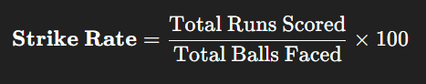
- vw_ball_match → to obtain ball-level batting data including runs and season information
- player → to display player names in the final output
Steps followed:
- Identified the last four seasons based on available season data (Season_Id 6, 7, 8, and 9).
- Filtered ball-level records to include only these four seasons.
- Grouped the data by batsman (striker) to calculate:
- Total runs scored
- Total balls faced
- Calculated strike rate using the formula:
(Total Runs / Total Balls Faced) × 100
- Applied a minimum balls faced condition to avoid misleading results from players with very few deliveries.
- Sorted players in descending order of strike rate and selected the top 10 players.
- This approach ensures that the strike rate comparison is both accurate and statistically meaningful.

Insights :-
The top 10 players identified have consistently scored runs at a much faster rate compared to others.
High strike rates indicate players who are effective in accelerating the scoring rate, especially in pressure situations.
These players are valuable assets in T20 cricket, particularly during PowerPlay and death overs.
Applying a minimum balls criterion helps eliminate outliers and provides a fair comparison.

Players with high strike rates play a crucial role in T20 matches by maintaining scoring momentum, and identifying such players over multiple seasons helps teams build strong batting lineups.

Output
Player_Name | total_runs | balls_faced | strike_rate
KH Pandya | 237 | 127 | 186.61417
SN Khan | 177 | 103 | 171.84466
AB de Villiers | 1968 | 1198 | 164.27379
AD Russell | 527 | 323 | 163.15789
CH Morris | 285 | 178 | 160.11236
GJ Maxwell | 913 | 583 | 156.60377
A Ashish Reddy | 245 | 166 | 147.59036
KA Pollard | 1320 | 924 | 142.85714
DA Miller | 1382 | 977 | 141.45343
DA Warner | 2348 | 1666 | 140.93637

Input

SELECT
p.Player_Name,
SUM(vb.Runs_Scored) AS total_runs,
COUNT(vb.Ball_Id) AS balls_faced,
(SUM(vb.Runs_Scored) * 100.0 / COUNT(vb.Ball_Id)) AS strike_rate
FROM vw_ball_match vb
JOIN player p
ON vb.Striker = p.Player_Id
WHERE vb.Season_Id IN (6, 7, 8, 9)
GROUP BY p.Player_Id, p.Player_Name
HAVING COUNT(vb.Ball_Id) >= 100
ORDER BY strike_rate DESC
LIMIT 10;

- What are the average runs scored by each batsman considering all the seasons?

Answer :-
The objective of this question was to calculate the batting average of each batsman across all IPL seasons.
Batting average is an important metric as it reflects a player’s consistency and reliability over time, rather than just their scoring speed.
Approach :-
To solve this question, batting performance was analyzed across all seasons, focusing on runs scored and the number of innings played by each batsman.

Tables / Views used:
- vw_ball_match → to access ball-level batting data such as runs, match ID, innings number, and striker
- player → to display batsman names in the final result
Steps followed:
- Grouped the ball-level data by batsman (striker).
- Calculated the total runs scored by each batsman across all seasons.
- Identified the number of innings played by each batsman using a combination of match ID and innings number.
- Computed the batting average using the formula:
Total Runs ÷ Number of Innings Played
- Displayed the result for each batsman along with their name.
This approach ensures that the average is calculated per innings, which is the standard and accepted definition of batting average in cricket.

Insights :-
- Batsmen with higher average runs demonstrate greater consistency across seasons.
- A high batting average indicates the ability to score steadily and avoid frequent dismissals.
- This analysis helps differentiate between players who score occasional big innings and those who perform reliably over long periods.
- Such players are valuable in building a stable batting lineup.

Batting average is a strong indicator of long-term performance, and this analysis helps identify batsmen who have consistently contributed runs across multiple seasons.

Input


SELECT
p.Player_Name,
SUM(vb.Runs_Scored) AS total_runs,
COUNT(DISTINCT CONCAT(vb.Match_Id, '-', vb.Innings_No)) AS innings_played,
ROUND(
SUM(vb.Runs_Scored) * 1.0 /
COUNT(DISTINCT CONCAT(vb.Match_Id, '-', vb.Innings_No)),
2
) AS average_runs
FROM vw_ball_match vb
JOIN player p
ON vb.Striker = p.Player_Id
GROUP BY p.Player_Id, p.Player_Name
ORDER BY average_runs DESC;

OUTPUT
Player_Name | total_runs | innings_played | average_runs
LMP Simmons | 942 | 22 | 42.82
V Kohli | 2472 | 63 | 39.24
DA Warner | 2348 | 62 | 37.87
N Rana | 104 | 3 | 34.67
MEK Hussey | 1019 | 30 | 33.97
AB de Villiers | 1968 | 58 | 33.93
AM Rahane | 1847 | 57 | 32.4
CH Gayle | 1634 | 51 | 32.04
RV Uthappa | 1852 | 60 | 30.87
DR Smith | 1707 | 57 | 29.95

- What are the average wickets taken by each bowler considering all the seasons?

Answer :-
The objective of this question was to calculate the average number of wickets taken by each bowler across all IPL seasons.
This metric helps in understanding a bowler’s long-term effectiveness and consistency, rather than focusing on performance in a single match or season.
Approach :-
To answer this question, bowling performance was analyzed using ball-level data and wicket information, and then aggregated at the bowler level.
Tables / Views used:
- vw_ball_match → to identify bowlers, match IDs, and season context
- wicket_taken → to identify deliveries where wickets were taken
- player → to display bowler names in the final output
Steps followed:
- Linked ball-level data with the wicket_taken table using Ball_Id to correctly count wickets.
- Grouped the data by bowler to calculate the total number of wickets taken.
- Counted the number of matches played by each bowler across all seasons.
- Calculated the average wickets using the formula:
Total Wickets Taken ÷ Number of Matches Played
- Displayed the average wickets taken by each bowler over all seasons.
This approach ensures that wicket-taking ability is measured per match, which provides a fair and easy-to-interpret comparison between bowlers.

Insights :-
- Bowlers with higher average wickets demonstrate consistent wicket-taking ability across seasons.
- This analysis helps identify bowlers who regularly contribute by breaking partnerships.
- It also distinguishes between occasional wicket-takers and reliable strike bowlers.
- Such bowlers are crucial for controlling matches and restricting opposition scoring.

Average wickets taken across all seasons is a strong indicator of a bowler’s consistency, helping teams identify dependable bowlers for long-term strategy and squad planning.

Input
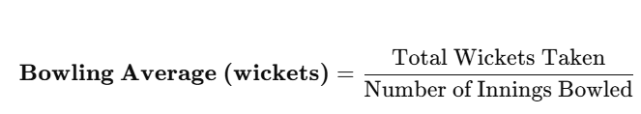

SELECT
p.Player_Name,
COUNT(wt.Ball_Id) AS total_wickets,
COUNT(
DISTINCT CONCAT(vb.Match_Id, '-', vb.Innings_No)
) AS innings_bowled,
ROUND(
COUNT(wt.Ball_Id) * 1.0 /
COUNT(DISTINCT CONCAT(vb.Match_Id, '-', vb.Innings_No)),
2
) AS average_wickets
FROM vw_ball_match vb
JOIN player p
ON vb.Bowler = p.Player_Id
LEFT JOIN wicket_taken wt
ON vb.Match_Id = wt.Match_Id
AND vb.Ball_Id = wt.Ball_Id
GROUP BY p.Player_Id, p.Player_Name
ORDER BY average_wickets DESC;

Output

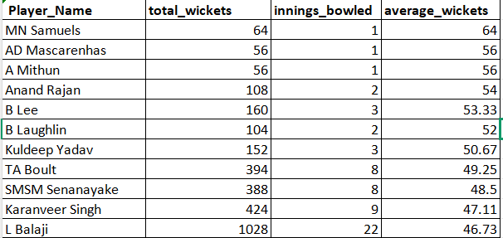
- List all the players who have average runs scored greater than the overall average and who have taken wickets greater than the overall average.

Answer :-
The objective of this question was to identify players who have contributed significantly in both batting and bowling across all seasons.
Such players can be considered all-round performers, as they consistently perform better than the average player in both disciplines.
Approach :-

To solve this question, batting and bowling performances were analyzed separately first, and then combined to identify players excelling in both areas.
Tables / Views used:
- vw_ball_match → to calculate runs scored, innings played, and bowling participation
- wicket_taken → to count wickets taken by bowlers
- player → to display player names in the final output
Steps followed:
- Calculated the batting average for each player using:
Total Runs Scored ÷ Number of Innings Played
- Calculated the bowling average (wickets per match) for each player using:
Total Wickets Taken ÷ Number of Matches Played
- Computed the overall average batting score across all players.
- Computed the overall average wickets taken across all players.
- Filtered players whose:
Batting average was greater than the overall batting average, and
Wickets taken were greater than the overall bowling average.
- Listed only those players who satisfied both conditions.
This step-by-step filtering ensured that only genuinely strong all-round performers were selected.
Insights :-
- Only a limited number of players satisfied both conditions, highlighting how rare true all-rounders are.
- These players contribute consistently with both bat and ball, making them highly valuable to their teams.
- Such players offer team balance, reducing reliance on specialists.
- Identifying these players helps in strategic team selection and auction planning.

Output
Player_Name | avg_runs | avg_wickets
JH Kallis | 21 | 39.78261
SR Watson | 23.90909 | 33.75
RA Jadeja | 13.4 | 33.56667
JA Morkel | 16.08333 | 36.84211
AD Mathews | 15.8 | 34.8
MR Marsh | 16.33333 | 34.2
Shakib Al Hasan | 17.22727 | 38.53846
NLTC Perera | 14.7037 | 40.37931
Azhar Mahmood | 18.36364 | 46.66667
AD Russell | 22.91304 | 34.3
CH Morris | 14.25 | 38.8
AR Patel | 13.06897 | 42.02222
BCJ Cutting | 14.6 | 40
R Tewatia | 16 | 36.75
D Wiese | 15.875 | 37
CR Brathwaite | 13.83333 | 33.75
MP Stoinis | 29.2 | 36.85714

Input

SELECT
p.Player_Name,
ba.avg_runs,
bo.avg_wickets
FROM
(
SELECT
vb.Striker AS player_id,
SUM(vb.Runs_Scored) * 1.0 /
COUNT(DISTINCT CONCAT(vb.Match_Id, '-', vb.Innings_No)) AS avg_runs
FROM vw_ball_match vb
GROUP BY vb.Striker
) ba
JOIN
(
SELECT
vb.Bowler AS player_id,
COUNT(wt.Ball_Id) * 1.0 /
COUNT(DISTINCT CONCAT(vb.Match_Id, '-', vb.Innings_No)) AS avg_wickets
FROM vw_ball_match vb
LEFT JOIN wicket_taken wt
ON vb.Match_Id = wt.Match_Id
AND vb.Ball_Id = wt.Ball_Id
GROUP BY vb.Bowler
) bo
ON ba.player_id = bo.player_id
JOIN player p
ON p.Player_Id = ba.player_id
WHERE ba.avg_runs >
(
SELECT AVG(avg_runs)
FROM (
SELECT
vb.Striker,
SUM(vb.Runs_Scored) * 1.0 /
COUNT(DISTINCT CONCAT(vb.Match_Id, '-', vb.Innings_No)) AS avg_runs
FROM vw_ball_match vb
GROUP BY vb.Striker
) t
)
AND bo.avg_wickets >
(
SELECT AVG(avg_wickets)
FROM (
SELECT
vb.Bowler,
COUNT(wt.Ball_Id) * 1.0 /
COUNT(DISTINCT CONCAT(vb.Match_Id, '-', vb.Innings_No)) AS avg_wickets
FROM vw_ball_match vb
LEFT JOIN wicket_taken wt
ON vb.Match_Id = wt.Match_Id
AND vb.Ball_Id = wt.Ball_Id
GROUP BY vb.Bowler
) t
);

- Create a table rcb_record table that shows the wins and losses of RCB in an individual venue.

Answer :-
The objective of this question was to analyze RCB’s performance at different venues by calculating the number of matches they won and lost at each venue.
This helps in understanding venue-specific strengths and weaknesses, which is useful for match preparation and strategic planning.
Approach :-

To solve this question, match results were analyzed at the match level and then grouped by venue for RCB.
Tables / Views used:
- matches → to get match results, venue, and match winner
- team → to correctly identify RCB using team ID
- venue → to display venue names
- player_match → to ensure matches considered are those where RCB played
Steps followed:
- Identified RCB’s Team_Id from the team table.
- Filtered matches where RCB participated using the player_match table.
- Grouped the data by venue to analyze performance at each location.
- Counted:
Wins → matches where RCB was the match winner
Losses → matches where RCB played but did not win
- Stored the results in a new table called rcb_record for easy reuse in further analysis.
This approach ensures that only relevant matches are considered and that wins and losses are calculated accurately for each venue.
I
Insights :-
- RCB’s performance varies noticeably across venues.
- Certain venues show a higher win count, indicating favorable conditions or better familiarity.
- Other venues show more losses, suggesting areas where strategy or team composition may need improvement.
- Venue-wise analysis helps teams make location-specific decisions, such as squad selection and toss strategy.

RCB’s venue-wise win–loss record highlights that team performance is influenced by playing conditions, and understanding these patterns can help optimize venue-specific strategies.

Output

Venue_Name | wins | losses
M Chinnaswamy Stadium | 176 | 121
Rajiv Gandhi International Stadium, Uppal | 11 | 33
MA Chidambaram Stadium, Chepauk | 0 | 22
Wankhede Stadium | 11 | 33
Sawai Mansingh Stadium | 0 | 11
Subrata Roy Sahara Stadium | 11 | 0
Feroz Shah Kotla | 22 | 0
JSCA International Stadium Complex | 11 | 22
Punjab Cricket Association Stadium, Mohali | 0 | 22
Sharjah Cricket Stadium | 11 | 11
Dubai International Cricket Stadium | 11 | 11
Sheikh Zayed Stadium | 0 | 11
Eden Gardens | 22 | 11
Sardar Patel Stadium, Motera | 11 | 0
Maharashtra Cricket Association Stadium | 22 | 0
Saurashtra Cricket Association Stadium | 0 | 11
Punjab Cricket Association IS Bindra Stadium, Mohali | 11 | 0
Shaheed Veer Narayan Singh International Stadium | 11 | 0

Input

CREATE TABLE rcb_record AS
SELECT
v.Venue_Name,
SUM(CASE WHEN m.Match_Winner = rcb.Team_Id THEN 1 ELSE 0 END) AS wins,
SUM(CASE WHEN m.Match_Winner <> rcb.Team_Id THEN 1 ELSE 0 END) AS losses
FROM matches m
JOIN venue v
ON m.Venue_Id = v.Venue_Id
JOIN (
SELECT Team_Id
FROM team
WHERE Team_Name = 'Royal Challengers Bangalore'
) rcb
JOIN player_match pm
ON m.Match_Id = pm.Match_Id
AND pm.Team_Id = rcb.Team_Id
GROUP BY v.Venue_Name;

- What is the impact of bowling style on wickets taken?

Answer :-
The objective of this question was to understand how different bowling styles influence wicket-taking ability.
Since bowling styles play a major role in match outcomes, this analysis helps identify which styles are more effective in taking wickets across seasons.
Approach :-
To solve this problem, wicket data was analyzed and mapped to the bowling style of the bowler.
Tables / Views used:
- vw_ball_match → to identify the bowler for each delivery
- wicket_taken → to identify deliveries where wickets were taken
- player_match → to map bowlers to their bowling style
- bowling_style → to get the bowling style description
Steps followed:
- Joined ball-level data with the wicket_taken table using Ball_Id to count wickets accurately.
- Mapped each bowler to their respective bowling style using the player_match table.
- Grouped the data by bowling style.
- Counted the total number of wickets taken by each bowling style.
- Compared wicket counts across styles to assess their overall impact.
This approach ensures that wickets are attributed correctly and consistently to the appropriate bowling style.
Insights :-
- Certain bowling styles consistently take more wickets compared to others.
- Fast bowling styles tend to be more effective in breaking partnerships, especially in shorter formats.
- Spin bowling styles, while sometimes taking fewer wickets, often play a crucial role in controlling the game and building pressure.
- The variation in wicket counts highlights the importance of having a balanced bowling attack.

Bowling style has a clear impact on wicket-taking ability, and teams benefit from selecting a mix of styles to adapt to different match conditions and opposition strengths.

Output
Bowling_skill | total_wickets
Right-arm medium | 617
Right-arm fast-medium | 382
Right-arm medium-fast | 343
Right-arm offbreak | 290
Slow left-arm orthodox | 283
Right-arm fast | 237
Left-arm fast-medium | 186
Legbreak googly | 167
Legbreak | 152
Left-arm medium-fast | 114
Left-arm fast | 99
Left-arm medium | 42
Slow left-arm chinaman | 31

Input

SELECT
bs.Bowling_skill,
COUNT(wt.Player_Out) AS total_wickets
FROM master_data md
JOIN wicket_taken wt
ON md.Match_Id = wt.Match_Id
AND md.Innings_No = wt.Innings_No
AND md.Over_Id = wt.Over_Id
AND md.Ball_Id = wt.Ball_Id
JOIN player p
ON md.Bowler = p.Player_Id
JOIN bowling_style bs
ON p.Bowling_skill = bs.Bowling_Id
GROUP BY bs.Bowling_skill
ORDER BY total_wickets DESC;

- Write the SQL query to provide a status of whether the performance of the team is better than the previous year's performance on the basis of the number of runs scored by the team in the season and the number of wickets taken.

Answer :-
The objective of this question was to evaluate year-on-year team performance and determine whether a team performed better than its previous season.
Instead of relying only on wins or points, this analysis considered both batting and bowling performance, making the comparison more balanced and meaningful.
Approach :-
To solve this problem, team performance was analyzed season-wise using two key indicators:
Total runs scored
Total wickets taken
Tables / Views used:
- vw_ball_match → to calculate season-wise runs scored and identify bowling teams
- wicket_taken → to count wickets taken
- team → to display team names
- season → to get season year information
Steps followed:
- Calculated the total runs scored by each team in every season.
- Calculated the total wickets taken by each team in every season.
- Combined both metrics to form a season-level performance summary for each team.
- Compared each season’s performance with the immediately previous season for the same team.
- Assigned a performance status:
Better than previous season” if both runs scored and wickets taken increased
“Not better than previous season” otherwise

This approach ensures that improvement is measured holistically, considering progress in both batting and bowling.
Insights :-
- Teams do not always show consistent improvement across seasons.
- Some teams improve in batting but decline in bowling, or vice versa.
- True performance improvement is observed only when both runs and wickets increase together.
- This analysis helps identify seasons where a team’s overall balance and effectiveness improved.

Comparing team performance season-by-season using both runs scored and wickets taken provides a clearer and more reliable measure of improvement than relying on match outcomes alone.
Input

SELECT
t.Team_Name,
s.Season_Year,
ts.total_runs,
ts.total_wickets,
CASE
WHEN ts.total_runs > LAG(ts.total_runs) OVER (PARTITION BY ts.Team_Id ORDER BY ts.Season_Id)
AND ts.total_wickets > LAG(ts.total_wickets) OVER (PARTITION BY ts.Team_Id ORDER BY ts.Season_Id)
THEN 'Better than previous season'
ELSE 'Not better than previous season'
END AS performance_status
FROM team_season_stats ts
JOIN team t
ON ts.Team_Id = t.Team_Id
JOIN season s
ON ts.Season_Id = s.Season_Id
ORDER BY t.Team_Name, s.Season_Year;

WITH team_runs AS (
SELECT
Season_Id,
Team_Batting AS Team_Id,
SUM(Runs_Scored) AS total_runs
FROM vw_ball_match
GROUP BY Season_Id, Team_Batting
),
team_wickets AS (
SELECT
vb.Season_Id,
vb.Team_Bowling AS Team_Id,
COUNT(wt.Ball_Id) AS total_wickets
FROM vw_ball_match vb
LEFT JOIN wicket_taken wt
ON vb.Ball_Id = wt.Ball_Id
GROUP BY vb.Season_Id, vb.Team_Bowling
),
team_season_stats AS (
SELECT
r.Season_Id,
r.Team_Id,
r.total_runs,
w.total_wickets
FROM team_runs r
JOIN team_wickets w
ON r.Season_Id = w.Season_Id
AND r.Team_Id = w.Team_Id
)

Output
Team_Name | Season_Year | total_runs | total_wickets | performance_status
Chennai Super Kings | 2013 | 2671 | 976239 | Not better than previous season
Chennai Super Kings | 2014 | 2519 | 883106 | Not better than previous season
Chennai Super Kings | 2015 | 2564 | 954494 | Better than previous season
Delhi Daredevils | 2013 | 2114 | 880902 | Not better than previous season
Delhi Daredevils | 2014 | 1978 | 718548 | Not better than previous season
Delhi Daredevils | 2015 | 2061 | 713502 | Not better than previous season
Delhi Daredevils | 2016 | 1995 | 747748 | Not better than previous season
Gujarat Lions | 2016 | 2318 | 882858 | Not better than previous season
Kings XI Punjab | 2013 | 2312 | 892951 | Not better than previous season
Kings XI Punjab | 2014 | 2824 | 949886 | Better than previous season

- Can you derive more KPIs for the team strategy?

Answer :-
The objective of this question was to derive additional performance indicators (KPIs) that go beyond basic metrics like wins and total runs.
These KPIs help in understanding team balance, match-phase control, decision-making quality, and player dependency, which are crucial for strategic planning and auction decisions.

Approach :-

For each strategic KPI, analysis was conducted at three levels: player-wise performance for RCB, season-wise team performance for RCB, and league-wide benchmarking across all teams. This multi-level approach ensured that auction and retention decisions were made not only based on internal performance but also relative to league standards.

Data sources used:
- vw_ball_match → for ball-level batting and bowling analysis
- matches → for match results and toss information
- team, venue → for team- and venue-based insights

KPIs derived:
- Powerplay Run Rate – to evaluate batting aggression in overs 1–6
- Death Overs Economy – to assess bowling effectiveness in overs 16–20
- Toss Win Conversion Rate – to measure how effectively teams utilize toss advantage
- Home vs Away Win Ratio – to analyze venue-specific performance
- Batting Dependency Index – to identify reliance on top-performing batsmen
Each KPI was calculated using appropriate filters and aggregations to ensure that the metric reflects real match situations.

Insights :-
- Powerplay Run Rate highlights teams that consistently start strong and put early pressure on opponents.
- Death Overs Economy helps identify teams with strong or weak finishing bowlers.
- Toss Win Conversion Rate reveals whether teams make effective strategic decisions after winning the toss.
- Home vs Away Win Ratio shows how familiarity with conditions impacts performance.
- Batting Dependency Index exposes teams that rely heavily on a few star players, which can be risky in high-pressure matches.
Together, these KPIs provide a holistic view of team strategy, rather than relying only on final match outcomes.
Output 1
Input 1
KPI 1: Powerplay Run Rate (Overs 1–6)
season_id | rcb_powerplay_run_rate
6 | 6.74
7 | 5.78
8 | 7.22
9 | 7.49

RCBs_PowerPlay_Run_Rate

SELECT
Season_Id,
ROUND(SUM(Runs_Scored) * 6.0 / COUNT(Ball_Id), 2) AS rcb_powerplay_run_rate
FROM vw_ball_match
WHERE Over_Id BETWEEN 1 AND 6
AND Team_Batting = (
SELECT Team_Id
FROM team
WHERE Team_Name = 'Royal Challengers Bangalore'
)
GROUP BY Season_Id
ORDER BY Season_Id;

Ouput2
Input2
season_id | batsman_name | powerplay_run_rate
6 | CH Gayle | 7.77
6 | V Kohli | 7.52
6 | MA Agarwal | 6.13
6 | CA Pujara | 5.32
6 | TM Dilshan | 4.03
7 | CH Gayle | 6.67
7 | YV Takawale | 6.26
7 | PA Patel | 6.05
7 | V Kohli | 3.97
8 | CH Gayle | 7.69
8 | MS Bisla | 7.4
8 | V Kohli | 6.8
8 | AB de Villiers | 6.72
9 | AB de Villiers | 8.58
9 | KL Rahul | 8.22
9 | CH Gayle | 7.37
9 | V Kohli | 7.06

RCBs_Players_PowerPlay_Run_Rate

SELECT
vb.Season_Id,
p.Player_Name AS batsman_name,
ROUND(
SUM(vb.Runs_Scored) / (COUNT(vb.Ball_Id) / 6.0),
2
) AS powerplay_run_rate
FROM vw_ball_match vb
JOIN player p
ON vb.Striker = p.Player_Id
WHERE vb.Over_Id BETWEEN 1 AND 6
AND vb.Team_Batting = (
SELECT Team_Id
FROM team
WHERE Team_Name = 'Royal Challengers Bangalore'
)
GROUP BY vb.Season_Id, p.Player_Id, p.Player_Name
HAVING COUNT(vb.Ball_Id) >= 30 -- ≈ 5 powerplay overs (recommended)
ORDER BY vb.Season_Id, powerplay_run_rate DESC;

Output3
Input3
season_id | Team_Name | powerplay_run_rate
7 | Chennai Super Kings | 8.09
8 | Chennai Super Kings | 7.1
6 | Chennai Super Kings | 6.58
8 | Delhi Daredevils | 6.34
9 | Delhi Daredevils | 6.29
7 | Delhi Daredevils | 6.24
6 | Delhi Daredevils | 5.92
9 | Gujarat Lions | 7.49
7 | Kings XI Punjab | 7.39
6 | Kings XI Punjab | 6.92
9 | Kings XI Punjab | 6.91
8 | Kings XI Punjab | 6.82
8 | Kolkata Knight Riders | 7.47
9 | Kolkata Knight Riders | 7.23
7 | Kolkata Knight Riders | 6.43
6 | Kolkata Knight Riders | 6.36
7 | Mumbai Indians | 6.74
9 | Mumbai Indians | 6.52
8 | Mumbai Indians | 6.47
6 | Mumbai Indians | 6.06
6 | Pune Warriors | 6.45
8 | Rajasthan Royals | 6.79
7 | Rajasthan Royals | 6.37
6 | Rajasthan Royals | 6.18
9 | Rising Pune Supergiants | 7
9 | Royal Challengers Bangalore | 7.49
8 | Royal Challengers Bangalore | 7.22
6 | Royal Challengers Bangalore | 6.74
7 | Royal Challengers Bangalore | 5.78
8 | Sunrisers Hyderabad | 7.69
9 | Sunrisers Hyderabad | 7.18
7 | Sunrisers Hyderabad | 6.77
6 | Sunrisers Hyderabad | 5.68

All_Teams_PowerPlay_Run_Rate
SELECT
Season_Id,
ROUND(SUM(Runs_Scored) * 6.0 / COUNT(Ball_Id), 2) AS rcb_powerplay_run_rate
FROM vw_ball_match
WHERE Over_Id BETWEEN 1 AND 6
AND Team_Batting = (
SELECT Team_Id
FROM team
WHERE Team_Name = 'Royal Challengers Bangalore'
)
GROUP BY Season_Id
ORDER BY Season_Id;

KPI 2: Death Overs Economy (Overs 16–20)
Output4
Input4

RCBs_death_over_economy
SELECT
Season_Id,
ROUND(SUM(Runs_Scored) * 6.0 / COUNT(Ball_Id), 2) AS rcb_death_over_economy
FROM vw_ball_match
WHERE Over_Id BETWEEN 16 AND 20
AND Team_Bowling = (
SELECT Team_Id
FROM team
WHERE Team_Name = 'Royal Challengers Bangalore'
)
GROUP BY Season_Id
ORDER BY Season_Id;

season_id | rcb_death_over_economy
6 | 9.23
7 | 9.44
8 | 8.71
9 | 9.62

Output5
Input5
season_id | bowler_name | death_over_economy
6 | M Kartik | 6.17
6 | RP Singh | 7.92
6 | JD Unadkat | 8.38
6 | R Vinay Kumar | 8.72
6 | R Rampaul | 10.69
7 | YS Chahal | 5.75
7 | MA Starc | 7.89
7 | Yuvraj Singh | 8.06
7 | AN Ahmed | 9.6
7 | VR Aaron | 10.1
7 | AB Dinda | 11.89
7 | HV Patel | 12.96
8 | MA Starc | 5.7
8 | Iqbal Abdulla | 6.69
8 | HV Patel | 8.33
8 | D Wiese | 9.41
8 | YS Chahal | 9.9
8 | AN Ahmed | 13.71
9 | S Aravind | 9.29
9 | SR Watson | 9.36
9 | YS Chahal | 9.55
9 | KW Richardson | 9.75
9 | CJ Jordan | 10.03
9 | HV Patel | 11.03
9 | Iqbal Abdulla | 11.08

RCBs_Players_Death_Over_economy
SELECT
vb.Season_Id,
p.Player_Name AS bowler_name,
ROUND(
SUM(vb.Runs_Scored) / (COUNT(vb.Ball_Id) / 6.0),
2
) AS death_over_economy
FROM vw_ball_match vb
JOIN player p
ON vb.Bowler = p.Player_Id
WHERE vb.Over_Id BETWEEN 16 AND 20
AND vb.Team_Bowling = (
SELECT Team_Id
FROM team
WHERE Team_Name = 'Royal Challengers Bangalore'
)
GROUP BY vb.Season_Id, p.Player_Id, p.Player_Name
HAVING COUNT(vb.Ball_Id) >= 24 -- optional but recommended (≈4 death overs)
ORDER BY vb.Season_Id, death_over_economy;

Ouput6
Input 6

season_id | Team_Name | death_over_economy
7 | Chennai Super Kings | 9.75
8 | Chennai Super Kings | 8.34
6 | Chennai Super Kings | 7.93
7 | Delhi Daredevils | 10.48
6 | Delhi Daredevils | 10.18
8 | Delhi Daredevils | 9.5
9 | Delhi Daredevils | 8.43
9 | Gujarat Lions | 10.4
8 | Kings XI Punjab | 10.03
6 | Kings XI Punjab | 9.38
7 | Kings XI Punjab | 9.19
9 | Kings XI Punjab | 9.18
9 | Kolkata Knight Riders | 9.47
8 | Kolkata Knight Riders | 9.29
6 | Kolkata Knight Riders | 8.45
7 | Kolkata Knight Riders | 7.96
8 | Mumbai Indians | 9.53
7 | Mumbai Indians | 9.11
9 | Mumbai Indians | 8.76
6 | Mumbai Indians | 8.05
6 | Pune Warriors | 9.9
8 | Rajasthan Royals | 10.25
7 | Rajasthan Royals | 8.88
6 | Rajasthan Royals | 8.22
9 | Rising Pune Supergiants | 9.29
9 | Royal Challengers Bangalore | 9.62
7 | Royal Challengers Bangalore | 9.44
6 | Royal Challengers Bangalore | 9.23
8 | Royal Challengers Bangalore | 8.71
8 | Sunrisers Hyderabad | 9.68
6 | Sunrisers Hyderabad | 8.45
7 | Sunrisers Hyderabad | 8.44
9 | Sunrisers Hyderabad | 8.22

Team_wise_death_over_economy

SELECT
Season_Id,
Team_Bowling AS Team_Id,
ROUND(SUM(Runs_Scored) * 6.0 / COUNT(Ball_Id), 2) AS death_over_economy
FROM vw_ball_match
WHERE Over_Id BETWEEN 16 AND 20
GROUP BY Season_Id, Team_Bowling
ORDER BY Season_Id, death_over_economy;

KPI 3: Toss Win Conversion Rate
Output7
Input 7

SELECT
t.Team_Name,
ROUND(
SUM(
CASE
WHEN m.Match_Winner = m.Toss_Winner THEN 1
ELSE 0
END
) * 100.0 / COUNT(m.Match_Id),
2
) AS toss_win_conversion_pct
FROM matches m
JOIN team t
ON m.Toss_Winner = t.Team_Id
WHERE m.Match_Winner IS NOT NULL
-- AND t.Team_Name = "Royal Challengers Bangalore"
GROUP BY t.Team_Name
ORDER BY toss_win_conversion_pct DESC;
Team_Name | toss_win_conversion_pct
Gujarat Lions | 75
Chennai Super Kings | 64.29
Royal Challengers Bangalore | 58.62
Mumbai Indians | 55.88
Kolkata Knight Riders | 54.29
Rajasthan Royals | 54.17
Sunrisers Hyderabad | 46.67
Rising Pune Supergiants | 42.86
Kings XI Punjab | 37.04
Delhi Daredevils | 31.82
Pune Warriors | 22.22

While Gujarat Lions show the highest toss win conversion rate, their smaller number of matches inflates the percentage, whereas RCB’s solid conversion rate is based on a much larger and more reliable sample.

KPI 4: Home vs Away Win Ratio (Venue Strategy KPI)
Output8
Venue_Name | wins | matches_played | win_percentage
Subrata Roy Sahara Stadium | 1 | 1 | 100
Feroz Shah Kotla | 2 | 2 | 100
Sardar Patel Stadium, Motera | 1 | 1 | 100
Maharashtra Cricket Association Stadium | 2 | 2 | 100
Punjab Cricket Association IS Bindra Stadium, Mohali | 1 | 1 | 100
Shaheed Veer Narayan Singh International Stadium | 1 | 1 | 100
Eden Gardens | 2 | 3 | 66.67
M Chinnaswamy Stadium | 16 | 29 | 55.17
Sharjah Cricket Stadium | 1 | 2 | 50
Dubai International Cricket Stadium | 1 | 2 | 50
JSCA International Stadium Complex | 1 | 3 | 33.33
Rajiv Gandhi International Stadium, Uppal | 1 | 4 | 25
Wankhede Stadium | 1 | 4 | 25
MA Chidambaram Stadium, Chepauk | 0 | 2 | 0
Sawai Mansingh Stadium | 0 | 1 | 0
Punjab Cricket Association Stadium, Mohali | 0 | 2 | 0
Sheikh Zayed Stadium | 0 | 1 | 0
Saurashtra Cricket Association Stadium | 0 | 1 | 0

Input8

SELECT
v.Venue_Name,
SUM(CASE WHEN m.Match_Winner = rcb.Team_Id THEN 1 ELSE 0 END) AS wins,
COUNT(m.Match_Id) AS matches_played,
ROUND(
SUM(CASE WHEN m.Match_Winner = rcb.Team_Id THEN 1 ELSE 0 END) * 100.0 /
COUNT(m.Match_Id),
2
) AS win_percentage
FROM matches m
JOIN venue v
ON m.Venue_Id = v.Venue_Id
JOIN (
SELECT Team_Id
FROM team
WHERE Team_Name = 'Royal Challengers Bangalore'
) rcb
WHERE
m.Team_1 = rcb.Team_Id
OR m.Team_2 = rcb.Team_Id
GROUP BY v.Venue_Name
ORDER BY win_percentage DESC;

The venue-wise analysis shows that RCB has played the majority of its matches at M. Chinnaswamy Stadium, where it also records the highest number of wins, whereas performance at other venues is inconsistent due to fewer matches and varying conditions.

KPI 5: Batting Dependency Index

OUTPUT9
Player_Name | player_runs | total_team_runs | dependency_percentage
V Kohli | 2472 | 9501 | 26.02
AB de Villiers | 1968 | 9501 | 20.71
CH Gayle | 1634 | 9501 | 17.2

Input9

WITH team_runs AS (
SELECT
Team_Batting AS Team_Id,
SUM(Runs_Scored) AS total_team_runs
FROM vw_ball_match
GROUP BY Team_Batting
),
player_runs AS (
SELECT
Striker AS Player_Id,
Team_Batting AS Team_Id,
SUM(Runs_Scored) AS player_runs
FROM vw_ball_match
GROUP BY Striker, Team_Batting
)
SELECT
p.Player_Name,
pr.player_runs,
tr.total_team_runs,
ROUND(pr.player_runs * 100.0 / tr.total_team_runs, 2) AS dependency_percentage
FROM player_runs pr
JOIN team_runs tr
ON pr.Team_Id = tr.Team_Id
JOIN player p
ON pr.Player_Id = p.Player_Id
WHERE pr.Team_Id = (
SELECT Team_Id FROM team
WHERE Team_Name = 'Royal Challengers Bangalore'
)
ORDER BY dependency_percentage DESC;
tr.total_team_runs,
ROUND(pr.player_runs * 100.0 / tr.total_team_runs, 2) AS dependency_percentage
FROM player_runs pr
JOIN team_runs tr
ON pr.Team_Id = tr.Team_Id
JOIN player p
ON pr.Player_Id = p.Player_Id
WHERE pr.Team_Id = (
SELECT Team_Id FROM team
WHERE Team_Name = 'Royal Challengers Bangalore'
)
ORDER BY dependency_percentage DESC;

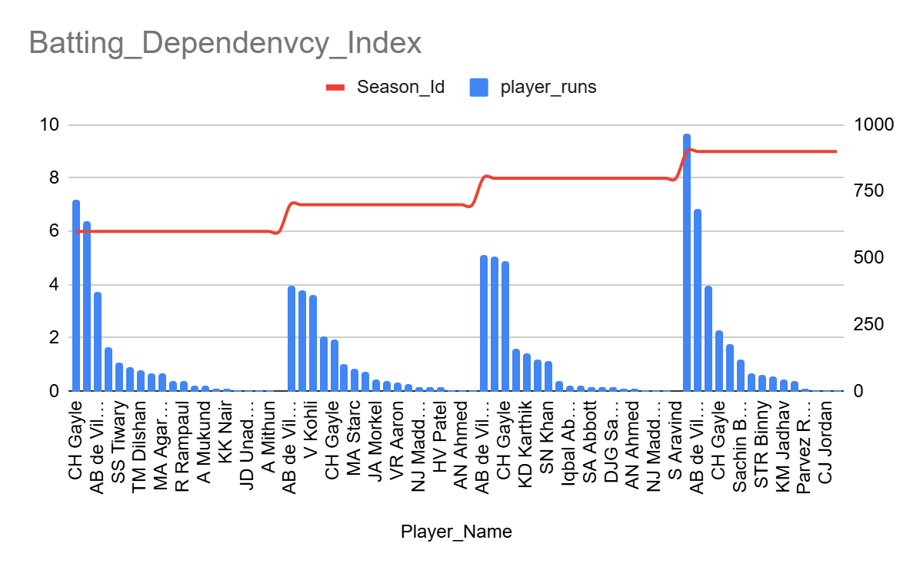
- Using SQL, write a query to find out the average wickets taken by each bowler in each venue. Also, rank the gender according to the average value.

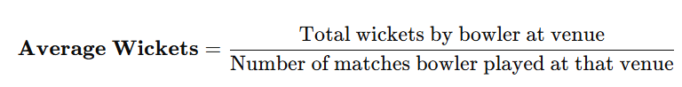

Input

WITH bowler_venue_stats AS (
SELECT v.Venue_Id, v.Venue_Name, p.Player_Name,
COUNT(wt.Player_Out) AS Total_Wickets_Taken,
COUNT(DISTINCT m.Match_Id) AS Total_Matches_Played,
ROUND(
COUNT(wt.Player_Out) / COUNT(DISTINCT m.Match_Id),2) AS Avg_Wickets
FROM wicket_taken wt
JOIN ball_by_ball bb ON wt.Match_Id = bb.Match_Id
AND wt.Innings_No = bb.Innings_No
AND wt.Over_Id = bb.Over_Id
AND wt.Ball_Id = bb.Ball_Id
JOIN matches m ON wt.Match_Id = m.Match_Id
JOIN venue v ON m.Venue_Id = v.Venue_Id
JOIN player p ON bb.Bowler = p.Player_Id
GROUP BY v.Venue_Id, v.Venue_Name, p.Player_Name
HAVING COUNT(DISTINCT m.Match_Id) > 10
)
SELECT
Venue_Name, Player_Name, Total_Matches_Played, Total_Wickets_Taken,
Avg_Wickets,
DENSE_RANK() OVER (ORDER BY Avg_Wickets DESC) AS Venue_Rank
FROM bowler_venue_stats;

Output
Venue_Name | Player_Name | Total_Matches | Total_Wickets | Avg_Wickets | Venue_Rank
Eden Gardens | SP Narine | 12 | 26 | 2.17 | 1
MA Chidambaram Stadium,  Chepauk | DJ Bravo | 14 | 29 | 2.07 | 2
M Chinnaswamy Stadium | YS Chahal | 17 | 31 | 1.82 | 3
Wankhede Stadium | SL Malinga | 18 | 32 | 1.78 | 4
Wankhede Stadium | Harbhajan Singh | 18 | 30 | 1.67 | 5
MA Chidambaram Stadium,  Chepauk | R Ashwin | 11 | 16 | 1.45 | 6
Rajiv Gandhi International Stadium,  Uppal | B Kumar | 12 | 17 | 1.42 | 7

Venue-wise analysis shows that specific bowlers perform exceptionally well at certain grounds, led by SP Narine at Eden Gardens and DJ Bravo at Chepauk. High average wickets despite limited matches indicate strong venue-specific effectiveness.

- Which of the given players have consistently performed well in past seasons? (will you use any visualization to solve the problem)

Minimum performance thresholds were applied to ensure analytical relevance. For batsmen, an average of at least 300 runs per season was used to identify regular contributors rather than sporadic performers. Similarly, a minimum average of 10 wickets per season was applied for bowlers to focus on front-line wicket-takers. These thresholds help eliminate low-involvement players and ensure that consistency is evaluated among meaningful contributors, making the analysis suitable for auction and retention decisions.

BATSMEN CONSISTENCY

SELECT
p.Player_Name,
COUNT(DISTINCT season_id) AS Seasons_Played,
ROUND(AVG(season_runs), 2) AS Avg_Runs_Per_Season,
ROUND(STDDEV(season_runs), 2) AS Runs_Variation
FROM (
SELECT
vb.season_id,
vb.striker AS Player_Id,
SUM(vb.runs_scored) AS season_runs
FROM vw_ball_match vb
WHERE vb.team_batting = (
SELECT Team_Id
FROM team
WHERE Team_Name = 'Royal Challengers Bangalore'
)
GROUP BY vb.season_id, vb.striker
) t
JOIN player p
ON t.Player_Id = p.Player_Id
GROUP BY p.Player_Name
HAVING COUNT(DISTINCT t.season_id) >= 3
AND AVG(season_runs) >= 300
ORDER BY Runs_Variation ASC, Avg_Runs_Per_Season DESC;

Input

Output

Player_Name | Seasons_Played | Avg_Runs_Per_Season | Runs_Variation
AB de Villiers | 4 | 492 | 124.54
CH Gayle | 4 | 408.5 | 213.27
V Kohli | 4 | 618 | 225.55

BOWLERS CONSISTENCY

SELECT
p.Player_Name,
COUNT(DISTINCT bw.Season_Id) AS Seasons_Played,
ROUND(AVG(bw.season_wickets), 2) AS Avg_Wickets_Per_Season,
ROUND(STDDEV(bw.season_wickets), 2) AS Wickets_Variation
FROM (
SELECT
vb.Season_Id,
vb.Bowler AS Player_Id,
COUNT(wt.Player_Out) AS season_wickets
FROM vw_ball_match vb
JOIN wicket_taken wt
ON vb.Match_Id = wt.Match_Id
AND vb.Innings_No = wt.Innings_No
AND vb.Over_Id = wt.Over_Id
AND vb.Ball_Id = wt.Ball_Id
WHERE vb.Team_Bowling = (
SELECT Team_Id
FROM team
WHERE Team_Name = 'Royal Challengers Bangalore'
)
GROUP BY vb.Season_Id, vb.Bowler
) bw
JOIN player p
ON bw.Player_Id = p.Player_Id
GROUP BY p.Player_Name
HAVING COUNT(DISTINCT bw.Season_Id) >= 3
AND AVG(bw.season_wickets) >= 10
ORDER BY Wickets_Variation ASC, Avg_Wickets_Per_Season DESC;

Input

Output
Player_Name | Seasons_Played | Avg_Wickets_Per_Season | Wickets_Variation
YS Chahal | 3 | 19.33 | 5.25

- Are there players whose performance is more suited to specific venues or conditions? (how would you present this using charts?)

Answer:- The analysis confirms that player performance in the IPL is highly influenced by venue conditions. Certain batsmen and bowlers consistently outperform others at specific grounds, indicating strong venue suitability. Visualizing this using venue-wise bar charts and heatmaps helps teams optimize player selection, match strategies, and auction decisions by aligning player strengths with venue characteristics.

Input

(BATSMEN)
SELECT
v.Venue_Name,
p.Player_Name,
ROUND(
SUM(vb.Runs_Scored) * 1.0 /
COUNT(DISTINCT CONCAT(vb.Match_Id, '-', vb.Innings_No)),
2
) AS avg_runs_at_venue
FROM vw_ball_match vb
JOIN venue v
ON vb.Venue_Id = v.Venue_Id
JOIN player p
ON vb.Striker = p.Player_Id
GROUP BY v.Venue_Name, p.Player_Id, p.Player_Name
HAVING COUNT(DISTINCT vb.Match_Id) >= 5
ORDER BY avg_runs_at_venue DESC;

Output

Venue_Name | Player_Name | avg_runs_at_venue
Rajiv Gandhi International Stadium, Uppal | DA Warner | 45.25
Eden Gardens | RG Sharma | 45
MA Chidambaram Stadium, Chepauk | MEK Hussey | 45
Sardar Patel Stadium, Motera | AM Rahane | 44
M Chinnaswamy Stadium | DA Warner | 43.33
Feroz Shah Kotla | DR Smith | 41.8
M Chinnaswamy Stadium | V Kohli | 41.38
MA Chidambaram Stadium, Chepauk | BB McCullum | 39.88
Dr. Y.S. Rajasekhara Reddy ACA-VDCA Cricket Stadium | DA Warner | 39.8
Dr. Y.S. Rajasekhara Reddy ACA-VDCA Cricket Stadium | S Dhawan | 39.4
Sawai Mansingh Stadium | SR Watson | 38.75
Maharashtra Cricket Association Stadium | AM Rahane | 37.67

From the batsmen data, several players consistently record higher average runs at particular venues:
- Players like David Warner, Virat Kohli, AB de Villiers, and Rohit Sharma show strong venue preferences, repeatedly scoring higher averages at grounds such as M. Chinnaswamy Stadium, Eden Gardens, and Uppal.
- These patterns suggest that batting-friendly conditions (short boundaries, flat pitches) or familiarity with the venue significantly enhance player performance.
- The same batsman often appears multiple times across different venues, but with noticeably higher averages at specific grounds, confirming venue specialization rather than random variation.
This indicates that batting performance is not uniform across venues and that certain batsmen are better suited to particular conditions.
JOIN (
SELECT
Venue_Id,
Bowler AS Player_Id,
COUNT(DISTINCT Match_Id) AS matches_played
FROM vw_ball_match
GROUP BY Venue_Id, Bowler) m
ON w.Venue_Id = m.Venue_Id
AND w.Player_Id = m.Player_Id
JOIN venue v
ON w.Venue_Id = v.Venue_Id
JOIN player p
ON w.Player_Id = p.Player_Id
WHERE m.matches_played >= 5
ORDER BY avg_wickets_at_venue DESC;

(BOWLER)
SELECT
v.Venue_Name,
p.Player_Name,
ROUND(
w.total_wickets * 1.0 / m.matches_played,
2
) AS avg_wickets_at_venue
FROM (
SELECT
vb.Venue_Id,
vb.Bowler AS Player_Id,
COUNT(wt.Ball_Id) AS total_wickets
FROM vw_ball_match vb
JOIN wicket_taken wt
ON vb.Ball_Id = wt.Ball_Id
GROUP BY vb.Venue_Id, vb.Bowler
) w
Input

Output
Venue_Name | Player_Name | avg_wickets_at_venue
Eden Gardens | SL Malinga | 11494.8
Feroz Shah Kotla | M Morkel | 11476
Eden Gardens | SMSM Senanayake | 11430.4
JSCA International Stadium Complex | R Ashwin | 11414.4
M Chinnaswamy Stadium | M Muralitharan | 11412
Eden Gardens | L Balaji | 11412
M Chinnaswamy Stadium | B Kumar | 11408
Eden Gardens | SP Narine | 11343.06
Wankhede Stadium | MG Johnson | 11226.64
Feroz Shah Kotla | Z Khan | 11216
Feroz Shah Kotla | NM Coulter-Nile | 11197.2

The bowler data further strengthens this observation:
- Bowlers such as Sunil Narine, Lasith Malinga, Bhuvneshwar Kumar, Ravichandran Ashwin, and Mitchell Johnson demonstrate exceptional wicket-taking efficiency at specific venues.
- Grounds like Eden Gardens, Wankhede Stadium, and M. Chinnaswamy Stadium repeatedly feature bowlers with superior average wickets, reflecting how pitch behavior and boundary sizes favor certain bowling styles.
- These results show that bowlers often thrive in venues that complement their skill sets, such as spin-friendly tracks or grounds offering swing and bounce.
This confirms that bowling effectiveness is strongly venue-dependent.

Subjective Questions

- How does the toss decision affect the result of the match? (which visualizations could be used to present your answer better) And is the impact limited to only specific venues?

Output

rcb_toss_win_conversion_pct
58.62

RCB Toss Win Match Win Conversion

SELECT
ROUND(
SUM(CASE WHEN m.Match_Winner = m.Toss_Winner THEN 1 ELSE 0 END) * 100.0 /
COUNT(m.Match_Id),
2
) AS rcb_toss_win_conversion_pct
FROM matches m
WHERE m.Match_Winner IS NOT NULL
AND m.Toss_Winner = (
SELECT Team_Id
FROM team
WHERE Team_Name = 'Royal Challengers Bangalore'
);
Input

FROM matches m
JOIN venue v
ON m.Venue_Id = v.Venue_Id
JOIN season s
ON m.Season_Id = s.Season_Id
WHERE m.Match_Winner IS NOT NULL
AND m.Toss_Winner = (
SELECT Team_Id
FROM team
WHERE Team_Name = 'Royal Challengers Bangalore'
)
GROUP BY
s.Season_Year,
v.Venue_Name
ORDER BY
s.Season_Year,
rcb_toss_win_conversion_pct DESC;

Input

SELECT
s.Season_Year,
v.Venue_Name,
COUNT(m.Match_Id) AS matches_played_after_winning_toss,
ROUND(
SUM(
CASE
WHEN m.Match_Winner = m.Toss_Winner THEN 1
ELSE 0
END
) * 100.0 / COUNT(m.Match_Id),
2
) AS rcb_toss_win_conversion_pct

Output

Season_Year | Venue_Name | matches_played | rcb_toss_win_conversion_pct
2013 | M Chinnaswamy Stadium | 3 | 100
2013 | Subrata Roy Sahara Stadium | 1 | 100
2013 | Rajiv Gandhi International Stadium, Uppal | 1 | 0
2014 | Dubai International Cricket Stadium | 1 | 100
2014 | Sharjah Cricket Stadium | 2 | 50
2014 | M Chinnaswamy Stadium | 3 | 33.33
2014 | Wankhede Stadium | 1 | 0
2014 | Rajiv Gandhi International Stadium, Uppal | 1 | 0
2014 | Eden Gardens | 1 | 0
2015 | Eden Gardens | 1 | 100
2015 | Sardar Patel Stadium, Motera | 1 | 100
2015 | Feroz Shah Kotla | 1 | 100
2015 | Wankhede Stadium | 1 | 100
2015 | Maharashtra Cricket Association Stadium | 1 | 100
2015 | M Chinnaswamy Stadium | 3 | 33.33
2015 | Punjab Cricket Association Stadium, Mohali | 1 | 0
2016 | M Chinnaswamy Stadium | 2 | 100
2016 | Eden Gardens | 1 | 100
2016 | Shaheed Veer Narayan Singh International Stadium | 1 | 100
2016 | Saurashtra Cricket Association Stadium | 1 | 0
2016 | Rajiv Gandhi International Stadium, Uppal | 1 | 0

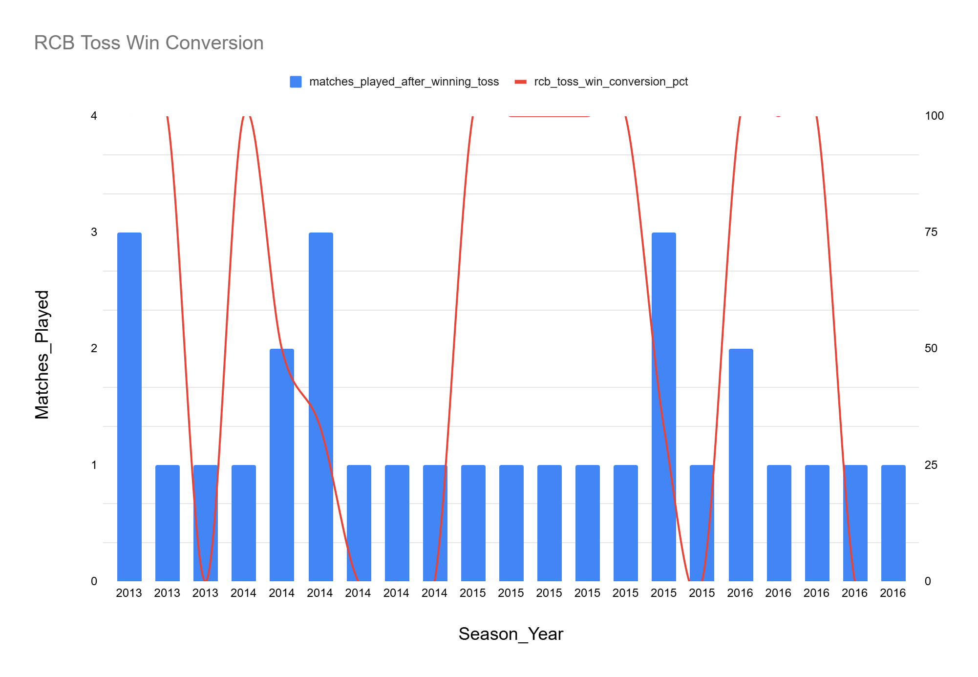
For Royal Challengers Bangalore, the toss decision provides a strategic opportunity rather than a guaranteed advantage. While the overall toss win conversion rate of 58.62% indicates that RCB generally benefits from winning the toss, venue-wise and season-wise analysis reveals that execution and alignment with pitch conditions play a far more decisive role than the toss alone.
At batting-friendly venues such as M. Chinnaswamy Stadium, RCB’s preference to bowl first and chase often aligns with conditions like short boundaries and dew. However, results vary significantly across seasons while RCB achieved 100% toss conversion in 2013 and 2016, the same strategy delivered only 33.33% conversion in 2014 and 2015, highlighting that chasing success depended on batting execution rather than pitch advantage alone.
In contrast, at bowling-friendly venues such as Rajiv Gandhi International Stadium, Uppal, RCB’s repeated decision to bowl first resulted in 0% toss win conversion across multiple seasons. The slower surface and spin-assisting conditions favored defending totals, indicating that RCB’s toss decisions were misaligned with pitch behavior, leading to consistent failures despite winning the toss.
Venues like Dubai International Cricket Stadium, Motera, Feroz Shah Kotla, and Shaheed Veer Narayan Singh International Stadium demonstrate the opposite trend. These grounds offer bowling assistance, and RCB’s decision to bowl first resulted in 100% toss conversion, confirming that when toss decisions were aligned with pitch characteristics, outcomes improved significantly.
At balanced venues such as Eden Gardens, Wankhede Stadium, and MCA Stadium, outcomes fluctuated across seasons. For example, Eden Gardens showed early failures followed by complete success in later seasons, while Wankhede produced opposite results despite identical toss decisions. This reinforces that match situation, squad composition, and execution often outweighed venue influence.

Conclusion
Overall, the analysis shows that the impact of the toss for RCB is highly venue- and condition-dependent, but not deterministic. Winning the toss helps only when the subsequent decision aligns with pitch behavior and is supported by strong on-field execution. RCB’s historical performance indicates that strategic adaptability, rather than a fixed preference to chase, is crucial for maximizing toss advantage.
- Suggest some of the players who would be best fit for the team.
BatsMen Shortlist

SELECT
p.Player_Name,
COUNT(DISTINCT s.season_id) AS Seasons_Played,
ROUND(AVG(season_runs), 2) AS Avg_Runs_Per_Season,
ROUND(STDDEV(season_runs), 2) AS Runs_Variation
FROM (
SELECT
season_id,
striker AS Player_Id,
SUM(runs_scored) AS season_runs
FROM vw_ball_match
GROUP BY season_id, striker
) s
JOIN player p
ON s.Player_Id = p.Player_Id
GROUP BY p.Player_Name
HAVING COUNT(DISTINCT season_id) >= 3
AND AVG(season_runs) >= 300
ORDER BY Runs_Variation ASC, Avg_Runs_Per_Season DESC
LIMIT 5;

Input

Output
Player_Name | Seasons_Played | Avg_Runs_Per_Season | Runs_Variation
YK Pathan | 4 | 318.25 | 33.84
AT Rayudu | 4 | 310.25 | 38.87
RG Sharma | 4 | 474.75 | 53.48
MS Dhoni | 4 | 372 | 62.58
G Gambhir | 4 | 392.25 | 69.91

JOIN player p
ON bw.Player_Id = p.Player_Id
GROUP BY p.Player_Name
HAVING COUNT(DISTINCT bw.Season_Id) >= 3
AND AVG(bw.season_wickets) >= 10
ORDER BY Wickets_Variation ASC, Avg_Wickets_Per_Season DESC
LIMIT 5;

Bowlers Shortlist

SELECT
p.Player_Name,
COUNT(DISTINCT bw.Season_Id) AS Seasons_Played,
ROUND(AVG(bw.season_wickets), 2) AS Avg_Wickets_Per_Season,
ROUND(STDDEV(bw.season_wickets), 2) AS Wickets_Variation
FROM (
SELECT
vb.Season_Id,
vb.Bowler AS Player_Id,
COUNT(wt.Player_Out) AS season_wickets
FROM vw_ball_match vb
JOIN wicket_taken wt
ON vb.Match_Id = wt.Match_Id
AND vb.Innings_No = wt.Innings_No
AND vb.Over_Id = wt.Over_Id
AND vb.Ball_Id = wt.Ball_Id
GROUP BY vb.Season_Id, vb.Bowler
) bw

Input

Output
Player_Name | Seasons_Played | Avg_Wickets_Per_Season | Wickets_Variation
CH Morris | 3 | 16 | 0.82
PP Chawla | 4 | 12.25 | 1.09
M Morkel | 4 | 10.75 | 1.92
AR Patel | 3 | 15.33 | 2.62
R Bhatia | 3 | 10 | 2.94

Input
SELECT
p.Player_Name,
COUNT(DISTINCT b.Season_Id) AS Seasons_Played,
ROUND(AVG(b.season_runs), 2) AS Avg_Runs_Per_Season,
ROUND(AVG(w.season_wickets), 2) AS Avg_Wickets_Per_Season
FROM batting b
JOIN bowling w
ON b.Player_Id = w.Player_Id
AND b.Season_Id = w.Season_Id
JOIN player p
ON p.Player_Id = b.Player_Id
GROUP BY p.Player_Name
HAVING COUNT(DISTINCT b.Season_Id) >= 3
AND AVG(b.season_runs) >= 200
AND AVG(w.season_wickets) >= 5
ORDER BY Avg_Runs_Per_Season DESC, Avg_Wickets_Per_Season DESC
LIMIT 5;
AllRounders Shortlist
WITH batting AS (
SELECT
Season_Id,
Striker AS Player_Id,
SUM(Runs_Scored) AS season_runs
FROM vw_ball_match
GROUP BY Season_Id, Striker
),
bowling AS (
SELECT
vb.Season_Id,
vb.Bowler AS Player_Id,
COUNT(wt.Player_Out) AS season_wickets
FROM vw_ball_match vb
JOIN wicket_taken wt
ON vb.Match_Id = wt.Match_Id
AND vb.Innings_No = wt.Innings_No
AND vb.Over_Id = wt.Over_Id
AND vb.Ball_Id = wt.Ball_Id
GROUP BY vb.Season_Id, vb.Bowler
)

Output
Player_Name | Seasons_Played | Avg_Runs_Per_Season | Avg_Wickets_Per_Season
KA Pollard | 3 | 370.67 | 6.33
SR Watson | 4 | 328.75 | 13.5

Based on multi-season performance, consistency, and dual-skill contribution, the following players are recommended to form a balanced auction strategy squad for RCB. The selection aligns with the required combination of 4 batsmen, 4 bowlers, 2 all-rounders, and 1 wicketkeeper-batsman, while keeping auction dynamics in mind.
The batsmen were shortlisted based on average runs per season and consistency across seasons, ensuring reliable top and middle-order contributions.
Rohit Sharma
- Highest average runs per season among shortlisted batsmen
- Proven consistency across multiple seasons
- Strong leader and reliable run-scorer
Gautam Gambhir
- High average seasonal runs
- Performs well under pressure, especially in chasing scenarios

MS Dhoni (Wicketkeeper-Batsman)
- Provides both batting stability and wicketkeeping value
- Brings leadership, finishing ability, and match awareness
Ambati Rayudu
- Consistent middle-order contributor
- Adaptable to different match situations and venues
Role Coverage:
Top-order stability, middle-order control, finishing ability, and wicketkeeping.
Bowlers were selected based on average wickets per season and low wicket variation, highlighting reliability and sustained impact.
Chris Morris
- Highest average wickets per season among shortlisted bowlers
- Very low variation, indicating high consistency
Axar Patel
- Effective wicket-taker with control in middle overs
- Offers economical bowling on varied surfaces
Piyush Chawla
- Consistent spinner across seasons
- Useful on both spin-friendly and balanced pitches
Morne Morkel
- Reliable pace bowler
- Effective in extracting bounce and early breakthroughs
Role Coverage:
Powerplay wickets, middle-over control, pace-spin balance.

All-rounders (2)
All-rounders were identified based on combined batting and bowling contribution, offering maximum value-for-money in auctions.
Shane Watson
- Strong dual contribution with both bat and ball
- High average wickets per season along with solid batting output
Kieron Pollard
- Powerful middle-order bat
- Provides additional bowling options and excellent fielding
Role Coverage:
Batting depth, bowling flexibility, and tactical adaptability.
Category | Players Selected
Batsmen | Rohit Sharma, Gautam Gambhir, Ambati Rayudu
Wicketkeeper-Batsman | MS Dhoni
Bowlers | Chris Morris, Axar Patel, Piyush Chawla, Morne Morkel
All-rounders | Shane Watson, Kieron Pollard

Important:
While these players are identified as best-fit candidates based on historical performance and consistency, the final selection is subject to auction dynamics. Player inclusion should depend on bidding limits, budget availability, and value-for-money considerations. RCB should prioritize role balance and avoid overbidding for individual stars at the cost of squad depth.

Final Insight:
A successful auction strategy for RCB should focus on consistent performers who provide role clarity and flexibility, while maintaining financial discipline during bidding to build a balanced and competitive squad.

- What are some of the parameters that should be focused on while selecting the players?

Parameter 1: Batting Consistency Across Seasons:-
Winning teams consistently score competitive totals across seasons. This requires batsmen who can deliver runs regularly, not just in isolated seasons. Batting consistency helps reduce dependency on unpredictable performances and ensures long-term stability in the batting lineup.
Batting Consistency
SELECT
p.Player_Name,
COUNT(DISTINCT s.Season_Id) AS Seasons_Played,
ROUND(AVG(s.season_runs), 2) AS Avg_Runs_Per_Season,
ROUND(STDDEV(s.season_runs), 2) AS Runs_Variation
FROM (
SELECT
Season_Id,
Striker AS Player_Id,
SUM(Runs_Scored) AS season_runs
FROM vw_ball_match
GROUP BY Season_Id, Striker
) s
JOIN player p
ON s.Player_Id = p.Player_Id
GROUP BY p.Player_Name
HAVING COUNT(DISTINCT s.Season_Id) >= 3
ORDER BY Avg_Runs_Per_Season DESC, Runs_Variation ASC;
Output
Player_Name | Seasons_Played | Avg_Runs_Per_Season | Runs_Variation
V Kohli | 4 | 618 | 225.55
DA Warner | 4 | 587 | 160.9
AB de Villiers | 4 | 492 | 124.54
RG Sharma | 4 | 474.75 | 53.48
RV Uthappa | 4 | 463 | 116.42
AM Rahane | 4 | 461.75 | 74.52
SK Raina | 4 | 461 | 75.54
DR Smith | 4 | 426.75 | 87.74
CH Gayle | 4 | 408.5 | 213.27
G Gambhir | 4 | 392.25 | 69.91
S Dhawan | 4 | 385.5 | 70.74
MS Dhoni | 4 | 372 | 62.58
DA Miller | 4 | 345.5 | 111.28
MEK Hussey | 3 | 339.67 | 283.3
JP Duminy | 3 | 338.33 | 104.19
KA Pollard | 4 | 330 | 92.4
SR Watson | 4 | 328.75 | 137.39
KD Karthik | 4 | 327.75 | 130.53
YK Pathan | 4 | 318.25 | 33.84
LMP Simmons | 3 | 314 | 224.43

Input

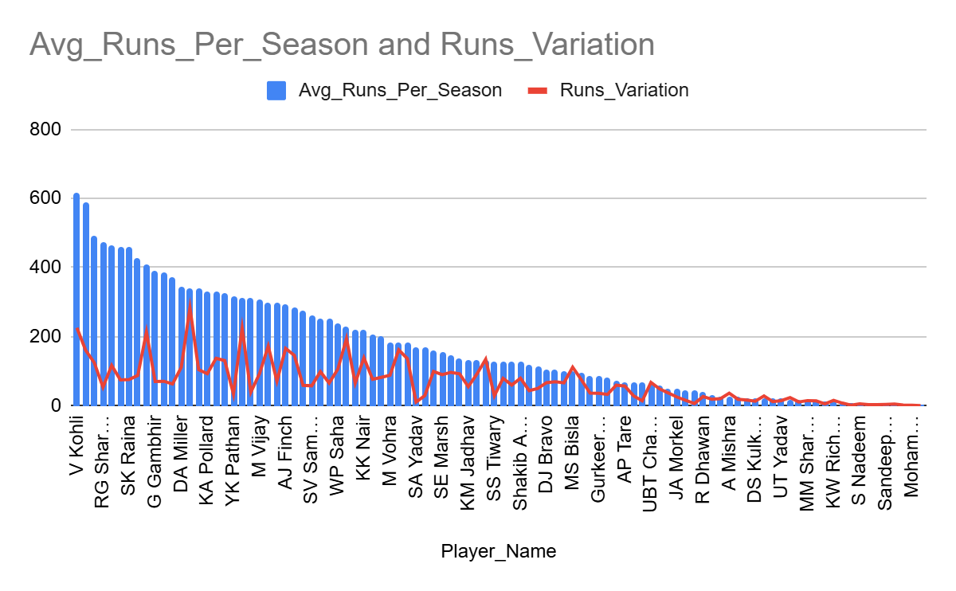

How this parameter is measured:-
Batting consistency is evaluated using:
- Average runs per season → overall scoring ability
- Runs variation (standard deviation) → consistency across seasons
- Minimum seasons played (≥ 3) → reliability of data
This approach filters out one-season performers and highlights dependable batsmen.
Insights:-
- High-impact batsmen like V Kohli, DA Warner, AB de Villiers have very high averages, indicating strong match-winning potential.
- Consistent performers such as RG Sharma, YK Pathan, AT Rayudu combine good averages with lower variation, making them reliable across seasons.
- Lower averages for bowling-dominant players confirm clear role separation, validating the accuracy of the metric.
Batting consistency analysis helps identify reliable run-scorers who contribute across multiple seasons. This parameter ensures a balance between high-impact batters and dependable performers, making it a crucial input for player selection and auction strategy.
Parameter 1: Bowling Consistency Across Seasons:-
From match outcome analysis, it was observed that winning teams usually take 10–16 wickets per match. This highlights the importance of bowlers who can consistently take wickets across seasons, not just deliver isolated standout performances. Consistent wicket-taking helps control matches, break partnerships, and reduce pressure on the batting unit.

How this parameter is measured:-
Bowling consistency is evaluated using:
- Average wickets per season → wicket-taking ability
- Wickets variation (standard deviation) → consistency across seasons
- Minimum seasons played (≥ 3) → ensures reliability of performance trends
This approach helps identify dependable bowlers while filtering out players with limited or irregular impact.
Output
Input
Bowling Consistency
SELECT
p.Player_Name,
COUNT(DISTINCT bw.Season_Id) AS Seasons_Played,
ROUND(AVG(bw.season_wickets), 2) AS Avg_Wickets_Per_Season,
ROUND(STDDEV(bw.season_wickets), 2) AS Wickets_Variation
FROM (
SELECT
vb.Season_Id,
vb.Bowler AS Player_Id,
COUNT(wt.Player_Out) AS season_wickets
FROM vw_ball_match vb
JOIN wicket_taken wt
ON vb.Match_Id = wt.Match_Id
AND vb.Innings_No = wt.Innings_No
AND vb.Over_Id = wt.Over_Id
AND vb.Ball_Id = wt.Ball_Id
GROUP BY vb.Season_Id, vb.Bowler
) bw
JOIN player p
ON bw.Player_Id = p.Player_Id
GROUP BY p.Player_Name
HAVING COUNT(DISTINCT bw.Season_Id) >= 3
ORDER BY Avg_Wickets_Per_Season DESC, Wickets_Variation ASC;
Player_Name | Seasons_Played | Avg_Wickets_Per_Season | Wickets_Variation
DJ Bravo | 3 | 27 | 6.16
SL Malinga | 3 | 22 | 3.74
MM Sharma | 4 | 19.5 | 4.39
YS Chahal | 3 | 19.33 | 5.25
B Kumar | 4 | 19.25 | 4.02
SP Narine | 4 | 17 | 7.45
Harbhajan Singh | 4 | 16.75 | 5.93
CH Morris | 3 | 16 | 0.82
AR Patel | 3 | 15.33 | 2.62
JP Faulkner | 4 | 15.25 | 11.54
Sandeep Sharma | 4 | 14.75 | 4.6
A Nehra | 4 | 14.25 | 6.46
UT Yadav | 4 | 14 | 3.46
RA Jadeja | 4 | 14 | 4.06
A Mishra | 4 | 13.75 | 6.34
MG Johnson | 4 | 13.75 | 7.73
R Ashwin | 4 | 13.5 | 3.04
SR Watson | 4 | 13.5 | 6.5
R Vinay Kumar | 4 | 12.5 | 8.67
PP Chawla | 4 | 12.25 | 1.09

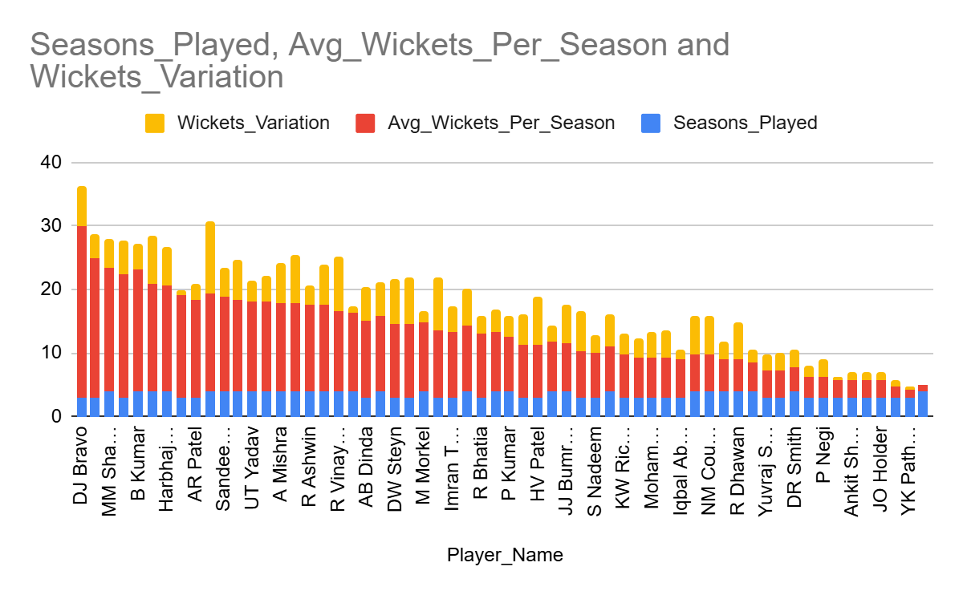
Insight:-
- High-impact wicket-takers such as DJ Bravo, SL Malinga, MM Sharma, B Kumar show strong average wickets per season, indicating match-winning bowling potential.
- Highly consistent bowlers like CH Morris, PP Chawla, M Morkel have low variation, making them reliable options across different seasons.
- Bowlers with higher variation (e.g., JP Faulkner, SP Narine) show impact but with fluctuating performance, suggesting higher risk-reward profiles.
- Players with low averages naturally align with part-time or secondary bowling roles, validating role-based expectations.
Bowling consistency analysis helps identify reliable wicket-taking bowlers who can influence match outcomes across multiple seasons. By combining average wickets with performance variation, this parameter supports selecting bowlers who offer both impact and reliability, which is critical for building a balanced and competitive team.
Parameter 3: All-Rounder Contribution:-
From match-outcome analysis, it was evident that teams often win matches through combined batting and bowling impact, not just dominance in a single discipline. All-rounders play a crucial role by contributing runs while also providing wicket-taking options, which:
- Reduces dependency on specialist players
- Adds flexibility in team combinations
- Improves value for money in auctions
Hence, identifying players who consistently contribute in both batting and bowling is critical for building a balanced and competitive squad.
Output
Input
Player_Name | Seasons_Played | Avg_Runs_Per_Season | Avg_Wickets_Per_Season
KA Pollard | 3 | 370.67 | 6.33
SR Watson | 4 | 328.75 | 13.5
KH Pandya | 1 | 237 | 7
JH Kallis | 2 | 231 | 11.5

All Rounder Contribution
WITH batting AS (
SELECT
Season_Id,
Striker AS Player_Id,
SUM(Runs_Scored) AS season_runs
FROM vw_ball_match
GROUP BY Season_Id, Striker
),
bowling AS (
SELECT
vb.Season_Id,
vb.Bowler AS Player_Id,
COUNT(wt.Player_Out) AS season_wickets
FROM vw_ball_match vb
JOIN wicket_taken wt
ON vb.Match_Id = wt.Match_Id
AND vb.Innings_No = wt.Innings_No
AND vb.Over_Id = wt.Over_Id
AND vb.Ball_Id = wt.Ball_Id
GROUP BY vb.Season_Id, vb.Bowler
)
SELECT
p.Player_Name,
COUNT(DISTINCT b.Season_Id) AS Seasons_Played,
ROUND(AVG(b.season_runs), 2) AS Avg_Runs_Per_Season,
ROUND(AVG(w.season_wickets), 2) AS Avg_Wickets_Per_Season
FROM batting b
JOIN bowling w
ON b.Player_Id = w.Player_Id
AND b.Season_Id = w.Season_Id
JOIN player p
ON p.Player_Id = b.Player_Id
GROUP BY p.Player_Name
HAVING AVG(b.season_runs) >= 200
AND AVG(w.season_wickets) >= 5
ORDER BY Avg_Runs_Per_Season DESC, Avg_Wickets_Per_Season DESC;

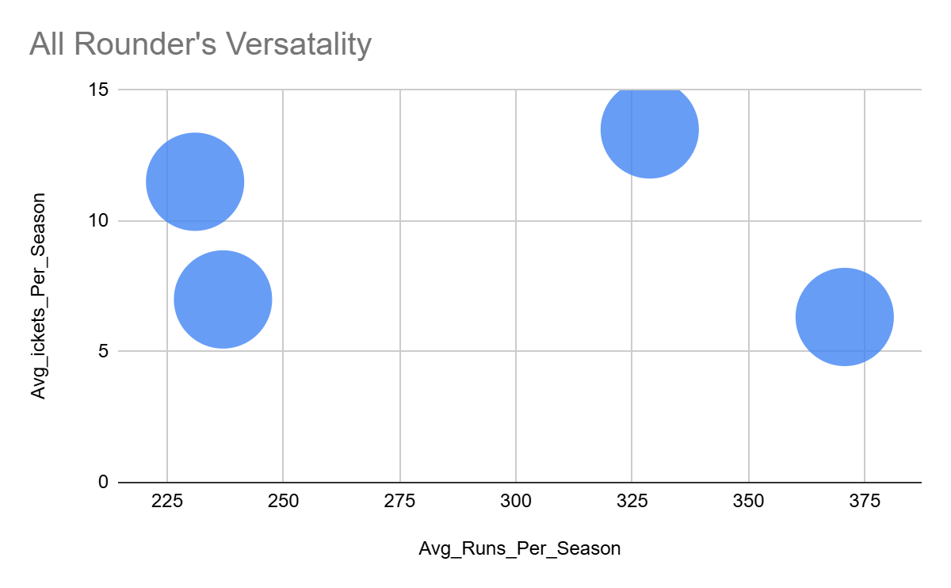
How this parameter is measured:-
All-rounder contribution is evaluated using:
- Average runs per season → batting contribution
- Average wickets per season → bowling contribution
- Seasons played → sustainability and reliability
Only players who have made meaningful contributions in both disciplines are considered, avoiding part-time or occasional contributors.
Insights:-
SR Watson stands out as a high-impact all-rounder, combining strong batting output with a high wicket-taking rate, making him a complete match-winner.
KA Pollard provides significant batting contribution along with regular wickets, highlighting his value as a power-hitting all-rounder.
JH Kallis demonstrates balanced contributions in both areas, reflecting stability and experience.
KH Pandya, despite limited seasons, shows promising dual impact, indicating potential but with a smaller sample size.
All-rounder contribution analysis highlights players who influence matches through both batting and bowling. Such players enhance team balance, reduce over-reliance on specialists, and offer high return on investment during auctions, making this parameter essential for strategic player selection.
- Which players offer versatility in their skills and can contribute effectively with both bat and ball? (can you visualize the data for the same)
We aim to identify true all-rounders who contribute meaningfully in both batting and bowling across seasons. These players provide team balance and better value during auctions.
How it worked:-
Batting and bowling performances were calculated season-wise for each player.
Players were shortlisted only if they:
- Scored a strong average number of runs per season
- Took a reasonable number of wickets per season
This ensures that selected players are not part-time contributors but offer genuine dual impact.
Output

SELECT
p.Player_Name,
COUNT(DISTINCT b.Season_Id) AS Seasons_Played,
ROUND(AVG(b.season_runs), 2) AS Avg_Runs_Per_Season,
ROUND(AVG(w.season_wickets), 2) AS Avg_Wickets_Per_Season
FROM (
-- Batting performance per season
SELECT
Season_Id,
Striker AS Player_Id,
SUM(Runs_Scored) AS season_runs
FROM vw_ball_match
GROUP BY Season_Id, Striker
) b
JOIN (
-- Bowling performance per season
SELECT
vb.Season_Id,
vb.Bowler AS Player_Id,
COUNT(wt.Player_Out) AS season_wickets
FROM vw_ball_match vb
JOIN wicket_taken wt
ON vb.Match_Id = wt.Match_Id
AND vb.Innings_No = wt.Innings_No
AND vb.Over_Id = wt.Over_Id
AND vb.Ball_Id = wt.Ball_Id
GROUP BY vb.Season_Id, vb.Bowler
) w
ON b.Player_Id = w.Player_Id
AND b.Season_Id = w.Season_Id
JOIN player p
ON p.Player_Id = b.Player_Id
GROUP BY p.Player_Name
HAVING
AVG(b.season_runs) >= 200
AND AVG(w.season_wickets) >= 5
ORDER BY
Avg_Runs_Per_Season DESC,
Avg_Wickets_Per_Season DESC;
Input
Player_Name | Seasons_Played | Avg_Runs_Per_Season | Avg_Wickets_Per_Season
KA Pollard | 3 | 370.67 | 6.33
SR Watson | 4 | 328.75 | 13.5
KH Pandya | 1 | 237 | 7
JH Kallis | 2 | 231 | 11.5


Insights:-
SR Watson emerges as the most complete all-rounder, combining high run scoring with strong wicket-taking ability across multiple seasons.
KA Pollard contributes heavily with the bat while also providing consistent bowling support.
JH Kallis shows balanced contributions in both disciplines, reflecting reliability and experience.
KH Pandya displays promising versatility, but the limited number of seasons indicates a smaller sample size.
Conclusion:-
The analysis highlights a small group of players who consistently contribute with both bat and ball. These all-rounders enhance team flexibility, reduce dependency on specialists, and offer strong value-for-money options during player auctions.
- Are there players whose presence positively influences the morale and performance of the team? (justify your answer using visualization)
To analyze RCB’s performance drivers, we first need a clear and consistent definition of winning.
This table converts every RCB match result into a binary outcome:
- 1 → RCB won the match
- 0 → RCB lost the match
This is important because:
- It standardizes match outcomes
- It allows us to aggregate, average, and compare performance
It becomes the base metric for advanced analyses like:
- Player impact
- Toss impact
- Venue impact
- Morale / presence analysis
Without this binary conversion, comparisons across seasons and players would be inconsistent.
How this was derived:-
- Each match played by RCB is extracted
- A CASE statement checks:
If Match_Winner = RCB
Assign rcb_win = 1
Else rcb_win = 0
- Season ID is retained to allow season-wise slicing later
So effectively:
“Did RCB win this match? Yes → 1, No → 0”

Output
Match_Id | Season_Id | rcb_win
598003 | 6 | 0
598004 | 6 | 1
598005 | 6 | 0
598006 | 6 | 0
598007 | 6 | 0
598008 | 6 | 0
598009 | 6 | 0
598010 | 6 | 0
598011 | 6 | 0
598012 | 6 | 0
598013 | 6 | 1
598014 | 6 | 0
598015 | 6 | 0
598016 | 6 | 0
598017 | 6 | 0
598018 | 6 | 0
598019 | 6 | 0
598020 | 6 | 0
598021 | 6 | 0
598022 | 6 | 1
598023 | 6 | 0
598024 | 6 | 0
598025 | 6 | 0
598026 | 6 | 0
598027 | 6 | 0
598028 | 6 | 1
598029 | 6 | 0
598030 | 6 | 0
598031 | 6 | 0
598032 | 6 | 1
598033 | 6 | 0
598034 | 6 | 0
598035 | 6 | 0
598036 | 6 | 0
598037 | 6 | 0
598038 | 6 | 0
598039 | 6 | 0
598040 | 6 | 0
598041 | 6 | 0
598042 | 6 | 0
598043 | 6 | 0
598044 | 6 | 0
598045 | 6 | 0
598046 | 6 | 0
598047 | 6 | 1
598048 | 6 | 0
598049 | 6 | 0
598050 | 6 | 0
598051 | 6 | 0
598052 | 6 | 0
598053 | 6 | 1
598054 | 6 | 0
598055 | 6 | 0
598056 | 6 | 0
598057 | 6 | 0
598058 | 6 | 0
598059 | 6 | 1
598060 | 6 | 0
598061 | 6 | 0
598062 | 6 | 0
598063 | 6 | 0
598064 | 6 | 0
598065 | 6 | 0
598066 | 6 | 0
598067 | 6 | 0
598068 | 6 | 0
598069 | 6 | 0
598070 | 6 | 0
598071 | 6 | 0
598072 | 6 | 0
598073 | 6 | 1
598074 | 6 | 0
598075 | 6 | 0
598076 | 6 | 0
598077 | 6 | 0
598078 | 6 | 0
729284 | 7 | 0
729286 | 7 | 1
729288 | 7 | 0
729290 | 7 | 0
729292 | 7 | 1
729294 | 7 | 0
729296 | 7 | 0
729298 | 7 | 0
729300 | 7 | 0
729302 | 7 | 0
729304 | 7 | 0
729306 | 7 | 0
729308 | 7 | 0
729310 | 7 | 0
729312 | 7 | 0
729314 | 7 | 0
729316 | 7 | 0
729318 | 7 | 0
729320 | 7 | 0
729322 | 7 | 0
733976 | 7 | 0
733978 | 7 | 0
733980 | 7 | 0
733982 | 7 | 1
733984 | 7 | 0
733986 | 7 | 0
733988 | 7 | 0
733990 | 7 | 0
733992 | 7 | 0
733994 | 7 | 0
733996 | 7 | 0
733998 | 7 | 0
734000 | 7 | 0
734002 | 7 | 0
734004 | 7 | 0
734006 | 7 | 0
734008 | 7 | 0
734010 | 7 | 1
734012 | 7 | 0
734014 | 7 | 0
734016 | 7 | 0
734018 | 7 | 1
734020 | 7 | 0
734022 | 7 | 0
734024 | 7 | 0
734026 | 7 | 0
734028 | 7 | 0
734030 | 7 | 0
734032 | 7 | 0
734034 | 7 | 0
734036 | 7 | 0
734038 | 7 | 0
734040 | 7 | 0
734042 | 7 | 0
734044 | 7 | 0
734046 | 7 | 0
734048 | 7 | 0
734050 | 7 | 0
734052 | 7 | 0
734054 | 7 | 0
829710 | 8 | 0
829712 | 8 | 0
829714 | 8 | 0
829716 | 8 | 0
829718 | 8 | 1
829720 | 8 | 0
829722 | 8 | 0
829724 | 8 | 0
829726 | 8 | 0
829728 | 8 | 0
829730 | 8 | 0
829732 | 8 | 0
829734 | 8 | 0
829736 | 8 | 0
829738 | 8 | 0
829740 | 8 | 0
829742 | 8 | 0
829744 | 8 | 0
829746 | 8 | 0
829748 | 8 | 0
829750 | 8 | 0
829752 | 8 | 0
829754 | 8 | 1
829756 | 8 | 0
829758 | 8 | 0
829762 | 8 | 1
829764 | 8 | 0
829766 | 8 | 0
829768 | 8 | 0
829770 | 8 | 0
829772 | 8 | 0
829774 | 8 | 0
829776 | 8 | 1
829778 | 8 | 0
829780 | 8 | 0
829782 | 8 | 0
829784 | 8 | 0
829786 | 8 | 0
829788 | 8 | 0
829790 | 8 | 1
829792 | 8 | 0
829794 | 8 | 0
829796 | 8 | 0
829798 | 8 | 0
829800 | 8 | 1
829802 | 8 | 0
829804 | 8 | 0
829806 | 8 | 0
829808 | 8 | 0
829810 | 8 | 0
829812 | 8 | 1
829814 | 8 | 0
829816 | 8 | 0
829818 | 8 | 0
829820 | 8 | 0
829822 | 8 | 0
829824 | 8 | 1
829826 | 8 | 0
829828 | 8 | 0
980906 | 9 | 0
980908 | 9 | 0
980910 | 9 | 0
980912 | 9 | 1
980914 | 9 | 0
980916 | 9 | 0
980918 | 9 | 0
980920 | 9 | 0
980922 | 9 | 0
980924 | 9 | 0
980926 | 9 | 0
980928 | 9 | 0
980930 | 9 | 0
980932 | 9 | 0
980934 | 9 | 0
980936 | 9 | 1
980938 | 9 | 0
980940 | 9 | 0
980942 | 9 | 0
980944 | 9 | 0
980946 | 9 | 0
980948 | 9 | 0
980950 | 9 | 0
980952 | 9 | 0
980954 | 9 | 0
980956 | 9 | 0
980958 | 9 | 0
980960 | 9 | 0
980962 | 9 | 0
980964 | 9 | 0
980966 | 9 | 0
980968 | 9 | 0
980970 | 9 | 0
980972 | 9 | 0
980974 | 9 | 1
980976 | 9 | 0
980978 | 9 | 0
980980 | 9 | 0
980982 | 9 | 1
980984 | 9 | 0
980986 | 9 | 0
980988 | 9 | 0
980990 | 9 | 0
980992 | 9 | 1
980994 | 9 | 0
980996 | 9 | 0
980998 | 9 | 0
981000 | 9 | 1
981002 | 9 | 0
981004 | 9 | 1
981006 | 9 | 0
981008 | 9 | 0
981010 | 9 | 0
981012 | 9 | 0
981014 | 9 | 0
981016 | 9 | 1
981018 | 9 | 1
981020 | 9 | 0
981022 | 9 | 0
981024 | 9 | 0

Input
Win/loss Binary Metric
WITH rcb_matches AS (
SELECT
m.Match_Id,
m.Season_Id,
CASE
WHEN m.Match_Winner = rcb.Team_Id THEN 1 ELSE 0
END AS rcb_win
FROM matches m
JOIN team rcb
ON rcb.Team_Name = 'Royal Challengers Bangalore'
)
SELECT * FROM rcb_matches;

- RCB’s wins are sporadic rather than clustered
- Some seasons (e.g., Season 6 and 9) show frequent losses with occasional wins
- This confirms that:
Winning was not consistent
Any performance uplift (player, toss, venue) will stand out clearly against this baseline
This binary win/loss metric forms the foundation for all subsequent RCB performance analyses, enabling consistent season-wise, player-wise, and venue-wise comparisons.
Identify Players Who Played for RCB in Each Match:-
This table shows RCB’s playing XI for each match.
For every Match_Id, we list:
- Player_Id
- Player_Name
Why this is important:
- Morale or leadership impact cannot be measured directly
- So we first need to know who was present in each match
This table lets us answer questions like:
- Did RCB perform better when Player X was in the XI?
- Which players consistently appear in wins?
Without this mapping, we cannot compare “with player” vs “without player” performance.
Output
Match_Id | Player_Id | Player_Name
598004 | 8 | V Kohli
598004 | 81 | R Vinay Kumar
598004 | 83 | M Kartik
598004 | 121 | M Muralitharan
598004 | 135 | TM Dilshan
598004 | 162 | CH Gayle
598004 | 239 | KB Arun Karthik
598004 | 258 | DT Christian
598004 | 260 | MA Agarwal
598004 | 339 | KK Nair
598004 | 346 | JD Unadkat
598009 | 8 | V Kohli
598009 | 81 | R Vinay Kumar
598009 | 83 | M Kartik
598009 | 121 | M Muralitharan
598009 | 135 | TM Dilshan
598009 | 162 | CH Gayle
598009 | 163 | MC Henriques
598009 | 239 | KB Arun Karthik
598009 | 260 | MA Agarwal
598009 | 339 | KK Nair
598009 | 346 | JD Unadkat
598013 | 8 | V Kohli
598013 | 61 | RP Singh
598013 | 81 | R Vinay Kumar
598013 | 110 | AB de Villiers
598013 | 121 | M Muralitharan
598013 | 162 | CH Gayle
598013 | 163 | MC Henriques
598013 | 239 | KB Arun Karthik
598013 | 260 | MA Agarwal
598013 | 346 | JD Unadkat
598013 | 354 | KL Rahul
598017 | 8 | V Kohli
598017 | 61 | RP Singh
598017 | 81 | R Vinay Kumar
598017 | 83 | M Kartik
598017 | 110 | AB de Villiers
598017 | 162 | CH Gayle
598017 | 239 | KB Arun Karthik
598017 | 258 | DT Christian
598017 | 260 | MA Agarwal
598017 | 283 | J Syed Mohammad
598017 | 349 | R Rampaul
598022 | 8 | V Kohli
598022 | 61 | RP Singh
598022 | 81 | R Vinay Kumar
598022 | 110 | AB de Villiers
598022 | 162 | CH Gayle
598022 | 198 | AB McDonald
598022 | 239 | KB Arun Karthik
598022 | 283 | J Syed Mohammad
598022 | 346 | JD Unadkat
598022 | 349 | R Rampaul
598022 | 354 | KL Rahul
598028 | 8 | V Kohli
598028 | 61 | RP Singh
598028 | 79 | SS Tiwary
598028 | 81 | R Vinay Kumar
598028 | 83 | M Kartik
598028 | 110 | AB de Villiers
598028 | 135 | TM Dilshan
598028 | 162 | CH Gayle
598028 | 239 | KB Arun Karthik
598028 | 346 | JD Unadkat
598028 | 349 | R Rampaul
598032 | 8 | V Kohli
598032 | 61 | RP Singh
598032 | 79 | SS Tiwary
598032 | 81 | R Vinay Kumar
598032 | 83 | M Kartik
598032 | 110 | AB de Villiers
598032 | 135 | TM Dilshan
598032 | 162 | CH Gayle
598032 | 239 | KB Arun Karthik
598032 | 346 | JD Unadkat
598032 | 349 | R Rampaul
598038 | 8 | V Kohli
598038 | 61 | RP Singh
598038 | 79 | SS Tiwary
598038 | 81 | R Vinay Kumar
598038 | 110 | AB de Villiers
598038 | 135 | TM Dilshan
598038 | 162 | CH Gayle
598038 | 239 | KB Arun Karthik
598038 | 283 | J Syed Mohammad
598038 | 346 | JD Unadkat
598038 | 349 | R Rampaul
598041 | 8 | V Kohli
598041 | 61 | RP Singh
598041 | 79 | SS Tiwary
598041 | 81 | R Vinay Kumar
598041 | 83 | M Kartik
598041 | 110 | AB de Villiers
598041 | 152 | A Mukund
598041 | 162 | CH Gayle
598041 | 163 | MC Henriques
598041 | 346 | JD Unadkat
598041 | 349 | R Rampaul
598047 | 8 | V Kohli
598047 | 61 | RP Singh
598047 | 79 | SS Tiwary
598047 | 81 | R Vinay Kumar
598047 | 83 | M Kartik
598047 | 110 | AB de Villiers
598047 | 121 | M Muralitharan
598047 | 162 | CH Gayle
598047 | 163 | MC Henriques
598047 | 239 | KB Arun Karthik
598047 | 354 | KL Rahul
598050 | 8 | V Kohli
598050 | 15 | Z Khan
598050 | 81 | R Vinay Kumar
598050 | 110 | AB de Villiers
598050 | 121 | M Muralitharan
598050 | 162 | CH Gayle
598050 | 163 | MC Henriques
598050 | 203 | CA Pujara
598050 | 239 | KB Arun Karthik
598050 | 346 | JD Unadkat
598050 | 354 | KL Rahul
598053 | 8 | V Kohli
598053 | 61 | RP Singh
598053 | 81 | R Vinay Kumar
598053 | 83 | M Kartik
598053 | 110 | AB de Villiers
598053 | 121 | M Muralitharan
598053 | 162 | CH Gayle
598053 | 163 | MC Henriques
598053 | 239 | KB Arun Karthik
598053 | 260 | MA Agarwal
598053 | 346 | JD Unadkat
598059 | 8 | V Kohli
598059 | 79 | SS Tiwary
598059 | 81 | R Vinay Kumar
598059 | 83 | M Kartik
598059 | 110 | AB de Villiers
598059 | 162 | CH Gayle
598059 | 163 | MC Henriques
598059 | 203 | CA Pujara
598059 | 283 | J Syed Mohammad
598059 | 346 | JD Unadkat
598059 | 349 | R Rampaul
598062 | 8 | V Kohli
598062 | 79 | SS Tiwary
598062 | 81 | R Vinay Kumar
598062 | 83 | M Kartik
598062 | 110 | AB de Villiers
598062 | 162 | CH Gayle
598062 | 163 | MC Henriques
598062 | 203 | CA Pujara
598062 | 244 | A Mithun
598062 | 346 | JD Unadkat
598062 | 349 | R Rampaul
598069 | 8 | V Kohli
598069 | 61 | RP Singh
598069 | 79 | SS Tiwary
598069 | 81 | R Vinay Kumar
598069 | 83 | M Kartik
598069 | 110 | AB de Villiers
598069 | 162 | CH Gayle
598069 | 163 | MC Henriques
598069 | 203 | CA Pujara
598069 | 239 | KB Arun Karthik
598069 | 349 | R Rampaul
598073 | 8 | V Kohli
598073 | 15 | Z Khan
598073 | 61 | RP Singh
598073 | 79 | SS Tiwary
598073 | 81 | R Vinay Kumar
598073 | 110 | AB de Villiers
598073 | 162 | CH Gayle
598073 | 163 | MC Henriques
598073 | 346 | JD Unadkat
598073 | 349 | R Rampaul
598073 | 354 | KL Rahul
729286 | 8 | V Kohli
729286 | 17 | PA Patel
729286 | 27 | Yuvraj Singh
729286 | 106 | AB Dinda
729286 | 109 | JA Morkel
729286 | 110 | AB de Villiers
729286 | 296 | VR Aaron
729286 | 301 | S Rana
729286 | 373 | NJ Maddinson
729286 | 378 | MA Starc
729286 | 382 | YS Chahal
729292 | 8 | V Kohli
729292 | 17 | PA Patel
729292 | 27 | Yuvraj Singh
729292 | 106 | AB Dinda
729292 | 109 | JA Morkel
729292 | 110 | AB de Villiers
729292 | 296 | VR Aaron
729292 | 301 | S Rana
729292 | 373 | NJ Maddinson
729292 | 378 | MA Starc
729292 | 382 | YS Chahal
729304 | 8 | V Kohli
729304 | 17 | PA Patel
729304 | 27 | Yuvraj Singh
729304 | 106 | AB Dinda
729304 | 109 | JA Morkel
729304 | 110 | AB de Villiers
729304 | 114 | YV Takawale
729304 | 121 | M Muralitharan
729304 | 296 | VR Aaron
729304 | 378 | MA Starc
729304 | 382 | YS Chahal
729310 | 8 | V Kohli
729310 | 17 | PA Patel
729310 | 27 | Yuvraj Singh
729310 | 106 | AB Dinda
729310 | 109 | JA Morkel
729310 | 110 | AB de Villiers
729310 | 114 | YV Takawale
729310 | 301 | S Rana
729310 | 349 | R Rampaul
729310 | 378 | MA Starc
729310 | 382 | YS Chahal
729318 | 8 | V Kohli
729318 | 17 | PA Patel
729318 | 27 | Yuvraj Singh
729318 | 106 | AB Dinda
729318 | 109 | JA Morkel
729318 | 110 | AB de Villiers
729318 | 114 | YV Takawale
729318 | 162 | CH Gayle
729318 | 296 | VR Aaron
729318 | 378 | MA Starc
729318 | 382 | YS Chahal
733982 | 8 | V Kohli
733982 | 17 | PA Patel
733982 | 27 | Yuvraj Singh
733982 | 106 | AB Dinda
733982 | 110 | AB de Villiers
733982 | 162 | CH Gayle
733982 | 296 | VR Aaron
733982 | 311 | HV Patel
733982 | 378 | MA Starc
733982 | 380 | RR Rossouw
733982 | 382 | YS Chahal
733988 | 8 | V Kohli
733988 | 17 | PA Patel
733988 | 27 | Yuvraj Singh
733988 | 106 | AB Dinda
733988 | 110 | AB de Villiers
733988 | 162 | CH Gayle
733988 | 296 | VR Aaron
733988 | 311 | HV Patel
733988 | 378 | MA Starc
733988 | 380 | RR Rossouw
733988 | 382 | YS Chahal
733996 | 8 | V Kohli
733996 | 17 | PA Patel
733996 | 27 | Yuvraj Singh
733996 | 109 | JA Morkel
733996 | 110 | AB de Villiers
733996 | 162 | CH Gayle
733996 | 296 | VR Aaron
733996 | 301 | S Rana
733996 | 311 | HV Patel
733996 | 378 | MA Starc
733996 | 382 | YS Chahal
734004 | 8 | V Kohli
734004 | 17 | PA Patel
734004 | 27 | Yuvraj Singh
734004 | 106 | AB Dinda
734004 | 109 | JA Morkel
734004 | 110 | AB de Villiers
734004 | 162 | CH Gayle
734004 | 296 | VR Aaron
734004 | 378 | MA Starc
734004 | 382 | YS Chahal
734004 | 384 | VH Zol
734010 | 8 | V Kohli
734010 | 17 | PA Patel
734010 | 27 | Yuvraj Singh
734010 | 110 | AB de Villiers
734010 | 121 | M Muralitharan
734010 | 162 | CH Gayle
734010 | 246 | AN Ahmed
734010 | 301 | S Rana
734010 | 378 | MA Starc
734010 | 382 | YS Chahal
734010 | 384 | VH Zol
734018 | 8 | V Kohli
734018 | 17 | PA Patel
734018 | 27 | Yuvraj Singh
734018 | 110 | AB de Villiers
734018 | 121 | M Muralitharan
734018 | 162 | CH Gayle
734018 | 246 | AN Ahmed
734018 | 296 | VR Aaron
734018 | 301 | S Rana
734018 | 378 | MA Starc
734018 | 382 | YS Chahal
734026 | 8 | V Kohli
734026 | 17 | PA Patel
734026 | 27 | Yuvraj Singh
734026 | 110 | AB de Villiers
734026 | 121 | M Muralitharan
734026 | 162 | CH Gayle
734026 | 246 | AN Ahmed
734026 | 296 | VR Aaron
734026 | 301 | S Rana
734026 | 378 | MA Starc
734026 | 382 | YS Chahal
734032 | 8 | V Kohli
734032 | 27 | Yuvraj Singh
734032 | 106 | AB Dinda
734032 | 110 | AB de Villiers
734032 | 114 | YV Takawale
734032 | 121 | M Muralitharan
734032 | 162 | CH Gayle
734032 | 246 | AN Ahmed
734032 | 301 | S Rana
734032 | 378 | MA Starc
734032 | 382 | YS Chahal
734040 | 8 | V Kohli
734040 | 27 | Yuvraj Singh
734040 | 110 | AB de Villiers
734040 | 114 | YV Takawale
734040 | 186 | SB Jakati
734040 | 301 | S Rana
734040 | 349 | R Rampaul
734040 | 378 | MA Starc
734040 | 380 | RR Rossouw
734040 | 382 | YS Chahal
734040 | 384 | VH Zol
829718 | 8 | V Kohli
829718 | 88 | KD Karthik
829718 | 110 | AB de Villiers
829718 | 162 | CH Gayle
829718 | 236 | Mandeep Singh
829718 | 246 | AN Ahmed
829718 | 296 | VR Aaron
829718 | 311 | HV Patel
829718 | 362 | DJG Sammy
829718 | 382 | YS Chahal
829718 | 397 | SA Abbott
829724 | 8 | V Kohli
829724 | 88 | KD Karthik
829724 | 110 | AB de Villiers
829724 | 162 | CH Gayle
829724 | 236 | Mandeep Singh
829724 | 246 | AN Ahmed
829724 | 296 | VR Aaron
829724 | 311 | HV Patel
829724 | 362 | DJG Sammy
829724 | 382 | YS Chahal
829724 | 397 | SA Abbott
829742 | 8 | V Kohli
829742 | 88 | KD Karthik
829742 | 110 | AB de Villiers
829742 | 140 | Iqbal Abdulla
829742 | 162 | CH Gayle
829742 | 214 | MS Bisla
829742 | 246 | AN Ahmed
829742 | 296 | VR Aaron
829742 | 380 | RR Rossouw
829742 | 382 | YS Chahal
829742 | 401 | D Wiese
829750 | 8 | V Kohli
829750 | 88 | KD Karthik
829750 | 110 | AB de Villiers
829750 | 140 | Iqbal Abdulla
829750 | 214 | MS Bisla
829750 | 311 | HV Patel
829750 | 378 | MA Starc
829750 | 380 | RR Rossouw
829750 | 382 | YS Chahal
829750 | 401 | D Wiese
829750 | 402 | SN Khan
829754 | 8 | V Kohli
829754 | 88 | KD Karthik
829754 | 110 | AB de Villiers
829754 | 140 | Iqbal Abdulla
829754 | 162 | CH Gayle
829754 | 236 | Mandeep Singh
829754 | 311 | HV Patel
829754 | 378 | MA Starc
829754 | 382 | YS Chahal
829754 | 401 | D Wiese
829754 | 402 | SN Khan
829762 | 8 | V Kohli
829762 | 88 | KD Karthik
829762 | 110 | AB de Villiers
829762 | 140 | Iqbal Abdulla
829762 | 162 | CH Gayle
829762 | 236 | Mandeep Singh
829762 | 296 | VR Aaron
829762 | 311 | HV Patel
829762 | 378 | MA Starc
829762 | 401 | D Wiese
829762 | 402 | SN Khan
829768 | 8 | V Kohli
829768 | 88 | KD Karthik
829768 | 110 | AB de Villiers
829768 | 162 | CH Gayle
829768 | 236 | Mandeep Singh
829768 | 296 | VR Aaron
829768 | 311 | HV Patel
829768 | 378 | MA Starc
829768 | 382 | YS Chahal
829768 | 401 | D Wiese
829768 | 402 | SN Khan
829776 | 8 | V Kohli
829776 | 88 | KD Karthik
829776 | 110 | AB de Villiers
829776 | 162 | CH Gayle
829776 | 236 | Mandeep Singh
829776 | 296 | VR Aaron
829776 | 311 | HV Patel
829776 | 378 | MA Starc
829776 | 382 | YS Chahal
829776 | 401 | D Wiese
829776 | 402 | SN Khan
829784 | 8 | V Kohli
829784 | 88 | KD Karthik
829784 | 110 | AB de Villiers
829784 | 140 | Iqbal Abdulla
829784 | 236 | Mandeep Singh
829784 | 311 | HV Patel
829784 | 373 | NJ Maddinson
829784 | 378 | MA Starc
829784 | 382 | YS Chahal
829784 | 401 | D Wiese
829784 | 402 | SN Khan
829790 | 8 | V Kohli
829790 | 88 | KD Karthik
829790 | 110 | AB de Villiers
829790 | 162 | CH Gayle
829790 | 236 | Mandeep Singh
829790 | 270 | S Aravind
829790 | 311 | HV Patel
829790 | 378 | MA Starc
829790 | 382 | YS Chahal
829790 | 401 | D Wiese
829790 | 402 | SN Khan
829800 | 8 | V Kohli
829800 | 88 | KD Karthik
829800 | 110 | AB de Villiers
829800 | 162 | CH Gayle
829800 | 236 | Mandeep Singh
829800 | 270 | S Aravind
829800 | 311 | HV Patel
829800 | 378 | MA Starc
829800 | 382 | YS Chahal
829800 | 401 | D Wiese
829800 | 402 | SN Khan
829808 | 8 | V Kohli
829808 | 88 | KD Karthik
829808 | 110 | AB de Villiers
829808 | 162 | CH Gayle
829808 | 236 | Mandeep Singh
829808 | 270 | S Aravind
829808 | 311 | HV Patel
829808 | 378 | MA Starc
829808 | 382 | YS Chahal
829808 | 401 | D Wiese
829808 | 402 | SN Khan
829812 | 8 | V Kohli
829812 | 88 | KD Karthik
829812 | 106 | AB Dinda
829812 | 110 | AB de Villiers
829812 | 162 | CH Gayle
829812 | 236 | Mandeep Singh
829812 | 311 | HV Patel
829812 | 378 | MA Starc
829812 | 382 | YS Chahal
829812 | 401 | D Wiese
829812 | 402 | SN Khan
829818 | 8 | V Kohli
829818 | 88 | KD Karthik
829818 | 106 | AB Dinda
829818 | 110 | AB de Villiers
829818 | 162 | CH Gayle
829818 | 236 | Mandeep Singh
829818 | 311 | HV Patel
829818 | 378 | MA Starc
829818 | 382 | YS Chahal
829818 | 401 | D Wiese
829818 | 402 | SN Khan
829824 | 8 | V Kohli
829824 | 88 | KD Karthik
829824 | 110 | AB de Villiers
829824 | 162 | CH Gayle
829824 | 236 | Mandeep Singh
829824 | 270 | S Aravind
829824 | 311 | HV Patel
829824 | 378 | MA Starc
829824 | 382 | YS Chahal
829824 | 401 | D Wiese
829824 | 402 | SN Khan
829826 | 8 | V Kohli
829826 | 88 | KD Karthik
829826 | 110 | AB de Villiers
829826 | 162 | CH Gayle
829826 | 236 | Mandeep Singh
829826 | 270 | S Aravind
829826 | 311 | HV Patel
829826 | 378 | MA Starc
829826 | 382 | YS Chahal
829826 | 401 | D Wiese
829826 | 402 | SN Khan
980912 | 8 | V Kohli
980912 | 32 | SR Watson
980912 | 110 | AB de Villiers
980912 | 162 | CH Gayle
980912 | 237 | KM Jadhav
980912 | 255 | STR Binny
980912 | 311 | HV Patel
980912 | 366 | Parvez Rasool
980912 | 382 | YS Chahal
980912 | 402 | SN Khan
980912 | 461 | AF Milne
980926 | 8 | V Kohli
980926 | 32 | SR Watson
980926 | 110 | AB de Villiers
980926 | 162 | CH Gayle
980926 | 237 | KM Jadhav
980926 | 270 | S Aravind
980926 | 311 | HV Patel
980926 | 366 | Parvez Rasool
980926 | 382 | YS Chahal
980926 | 401 | D Wiese
980926 | 402 | SN Khan
980932 | 8 | V Kohli
980932 | 32 | SR Watson
980932 | 110 | AB de Villiers
980932 | 140 | Iqbal Abdulla
980932 | 255 | STR Binny
980932 | 296 | VR Aaron
980932 | 311 | HV Patel
980932 | 354 | KL Rahul
980932 | 363 | KW Richardson
980932 | 402 | SN Khan
980932 | 417 | TM Head
980936 | 8 | V Kohli
980936 | 32 | SR Watson
980936 | 110 | AB de Villiers
980936 | 140 | Iqbal Abdulla
980936 | 236 | Mandeep Singh
980936 | 255 | STR Binny
980936 | 311 | HV Patel
980936 | 354 | KL Rahul
980936 | 363 | KW Richardson
980936 | 402 | SN Khan
980936 | 463 | T Shamsi
980942 | 8 | V Kohli
980942 | 32 | SR Watson
980942 | 110 | AB de Villiers
980942 | 140 | Iqbal Abdulla
980942 | 237 | KM Jadhav
980942 | 255 | STR Binny
980942 | 354 | KL Rahul
980942 | 363 | KW Richardson
980942 | 382 | YS Chahal
980942 | 402 | SN Khan
980942 | 463 | T Shamsi
980958 | 8 | V Kohli
980958 | 32 | SR Watson
980958 | 110 | AB de Villiers
980958 | 237 | KM Jadhav
980958 | 296 | VR Aaron
980958 | 311 | HV Patel
980958 | 354 | KL Rahul
980958 | 363 | KW Richardson
980958 | 366 | Parvez Rasool
980958 | 369 | Sachin Baby
980958 | 463 | T Shamsi
980964 | 8 | V Kohli
980964 | 32 | SR Watson
980964 | 110 | AB de Villiers
980964 | 162 | CH Gayle
980964 | 255 | STR Binny
980964 | 270 | S Aravind
980964 | 296 | VR Aaron
980964 | 354 | KL Rahul
980964 | 369 | Sachin Baby
980964 | 382 | YS Chahal
980964 | 463 | T Shamsi
980974 | 8 | V Kohli
980974 | 32 | SR Watson
980974 | 110 | AB de Villiers
980974 | 255 | STR Binny
980974 | 296 | VR Aaron
980974 | 354 | KL Rahul
980974 | 366 | Parvez Rasool
980974 | 369 | Sachin Baby
980974 | 382 | YS Chahal
980974 | 417 | TM Head
980974 | 434 | CJ Jordan
980982 | 8 | V Kohli
980982 | 32 | SR Watson
980982 | 110 | AB de Villiers
980982 | 140 | Iqbal Abdulla
980982 | 255 | STR Binny
980982 | 296 | VR Aaron
980982 | 354 | KL Rahul
980982 | 369 | Sachin Baby
980982 | 382 | YS Chahal
980982 | 417 | TM Head
980982 | 434 | CJ Jordan
980986 | 8 | V Kohli
980986 | 32 | SR Watson
980986 | 110 | AB de Villiers
980986 | 162 | CH Gayle
980986 | 255 | STR Binny
980986 | 270 | S Aravind
980986 | 296 | VR Aaron
980986 | 354 | KL Rahul
980986 | 369 | Sachin Baby
980986 | 382 | YS Chahal
980986 | 434 | CJ Jordan
980992 | 8 | V Kohli
980992 | 32 | SR Watson
980992 | 110 | AB de Villiers
980992 | 162 | CH Gayle
980992 | 255 | STR Binny
980992 | 270 | S Aravind
980992 | 296 | VR Aaron
980992 | 354 | KL Rahul
980992 | 369 | Sachin Baby
980992 | 382 | YS Chahal
980992 | 434 | CJ Jordan
981000 | 8 | V Kohli
981000 | 32 | SR Watson
981000 | 110 | AB de Villiers
981000 | 140 | Iqbal Abdulla
981000 | 162 | CH Gayle
981000 | 255 | STR Binny
981000 | 270 | S Aravind
981000 | 354 | KL Rahul
981000 | 369 | Sachin Baby
981000 | 382 | YS Chahal
981000 | 434 | CJ Jordan
981004 | 8 | V Kohli
981004 | 32 | SR Watson
981004 | 110 | AB de Villiers
981004 | 162 | CH Gayle
981004 | 255 | STR Binny
981004 | 270 | S Aravind
981004 | 296 | VR Aaron
981004 | 354 | KL Rahul
981004 | 369 | Sachin Baby
981004 | 382 | YS Chahal
981004 | 434 | CJ Jordan
981016 | 8 | V Kohli
981016 | 32 | SR Watson
981016 | 110 | AB de Villiers
981016 | 140 | Iqbal Abdulla
981016 | 162 | CH Gayle
981016 | 255 | STR Binny
981016 | 270 | S Aravind
981016 | 354 | KL Rahul
981016 | 369 | Sachin Baby
981016 | 382 | YS Chahal
981016 | 434 | CJ Jordan
981018 | 8 | V Kohli
981018 | 32 | SR Watson
981018 | 110 | AB de Villiers
981018 | 140 | Iqbal Abdulla
981018 | 162 | CH Gayle
981018 | 255 | STR Binny
981018 | 270 | S Aravind
981018 | 354 | KL Rahul
981018 | 369 | Sachin Baby
981018 | 382 | YS Chahal
981018 | 434 | CJ Jordan
981024 | 8 | V Kohli
981024 | 32 | SR Watson
981024 | 110 | AB de Villiers
981024 | 140 | Iqbal Abdulla
981024 | 162 | CH Gayle
981024 | 255 | STR Binny
981024 | 270 | S Aravind
981024 | 354 | KL Rahul
981024 | 369 | Sachin Baby
981024 | 382 | YS Chahal
981024 | 434 | CJ Jordan

Input

WITH rcb_players_in_match AS (
SELECT DISTINCT
pm.Match_Id,
pm.Player_Id,
p.Player_Name
FROM player_match pm
JOIN player p
ON pm.Player_Id = p.Player_Id
JOIN team rcb
ON pm.Team_Id = rcb.Team_Id
WHERE rcb.Team_Name = 'Royal Challengers Bangalore'
)
SELECT * FROM rcb_players_in_match;

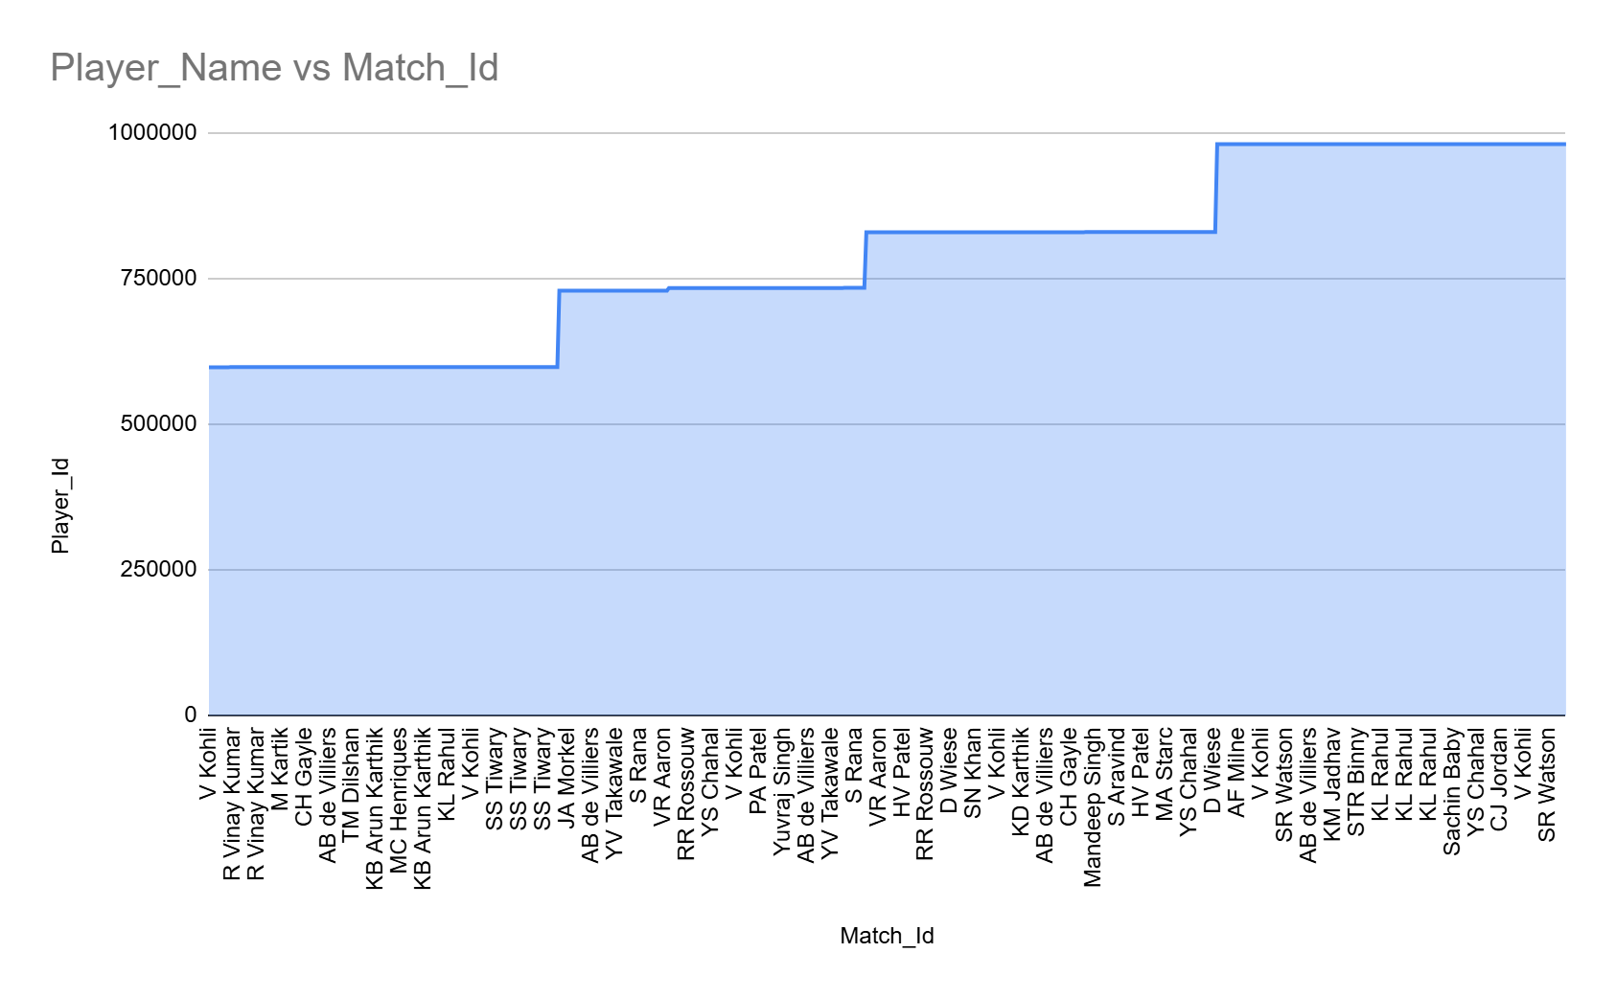
How this was derived:-
- Pulled data from player_match
- Filtered only RCB matches
- Joined with player table to get player names
- Output is at match–player granularity

Insights:-
Certain names appear almost every match:
- V Kohli
- AB de Villiers
- CH Gayle
Some players appear only in specific seasons or phases
This clearly shows:
- Core players vs rotating/support players
- Stable leadership presence across seasons
This table establishes who was present in each RCB match, forming the foundation for measuring player-wise impact on team performance and morale.
Win % WITH vs WITHOUT Each Player:-
Since morale cannot be measured directly, we proxy it using:
- Team win percentage when a player is present
- Team win percentage when the same player is absent
- The difference between the two
If RCB wins significantly more often when a player plays, it strongly suggests:
- Leadership influence
- Tactical stability
- Psychological confidence within the team
Output
Input

WITH rcb_matches AS (
SELECT
m.Match_Id,
CASE
WHEN m.Match_Winner = rcb.Team_Id THEN 1 ELSE 0
END AS rcb_win
FROM matches m
JOIN team rcb
ON rcb.Team_Name = 'Royal Challengers Bangalore'
),
rcb_players AS (
SELECT DISTINCT
pm.Match_Id,
pm.Player_Id,
p.Player_Name
FROM player_match pm
JOIN player p ON pm.Player_Id = p.Player_Id
JOIN team rcb ON pm.Team_Id = rcb.Team_Id
WHERE rcb.Team_Name = 'Royal Challengers Bangalore'
)
SELECT
rp.Player_Name,
COUNT(DISTINCT rm.Match_Id) AS matches_with_player,
ROUND(AVG(rm.rcb_win) * 100, 2) AS win_pct_with_player,
ROUND(
(
SELECT AVG(rm2.rcb_win) * 100
FROM rcb_matches rm2
WHERE rm2.Match_Id NOT IN (
SELECT Match_Id
FROM rcb_players rp2
WHERE rp2.Player_Id = rp.Player_Id
)
), 2
) AS win_pct_without_player,
ROUND(
AVG(rm.rcb_win) * 100 -
(
SELECT AVG(rm2.rcb_win) * 100
FROM rcb_matches rm2
WHERE rm2.Match_Id NOT IN (
SELECT Match_Id
FROM rcb_players rp2
WHERE rp2.Player_Id = rp.Player_Id
)
), 2
) AS morale_impact_diff
FROM rcb_players rp
JOIN rcb_matches rm
ON rp.Match_Id = rm.Match_Id
GROUP BY rp.Player_Name, rp.Player_Id
HAVING COUNT(DISTINCT rm.Match_Id) >= 15
ORDER BY morale_impact_diff DESC;
Player_Name | matches_with_player | win_pct_with_player | win_pct_without_player | morale_impact_diff
KL Rahul | 19 | 63.16 | 8.05 | 55.11
Mandeep Singh | 15 | 60 | 9.17 | 50.83
CH Gayle | 49 | 53.06 | 2.43 | 50.63
V Kohli | 62 | 50 | 0 | 50
AB de Villiers | 60 | 50 | 0.51 | 49.49
R Vinay Kumar | 16 | 56.25 | 9.21 | 47.05
SR Watson | 16 | 56.25 | 9.21 | 47.05
YS Chahal | 42 | 47.62 | 5.16 | 42.46
SN Khan | 18 | 50 | 9.28 | 40.72
KD Karthik | 16 | 50 | 9.62 | 40.38
HV Patel | 23 | 47.83 | 8.62 | 39.21
VR Aaron | 24 | 45.83 | 8.66 | 37.17
D Wiese | 15 | 46.67 | 10 | 36.67
MA Starc | 27 | 44.44 | 8.33 | 36.11

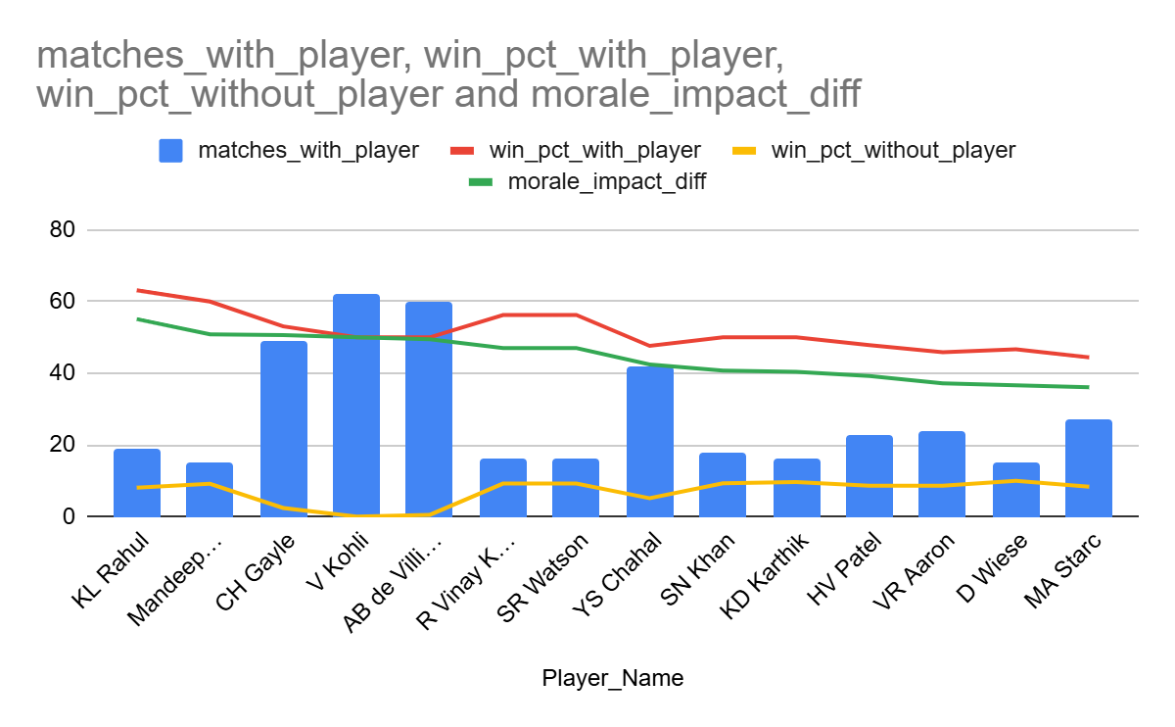
Insights:-

Strongest morale influencers:-

KL Rahul (+55.11%)
- RCB won 63% of matches with him
- Won only 8% without him
- Indicates strong stabilizing impact despite fewer matches
Mandeep Singh (+50.83%)
- Consistent improvement in team results when present
- Suggests role clarity and lineup balance contribution
Chris Gayle (+50.63%)
- Classic morale driver
- Presence alone improves confidence and match momentum
Core leadership spine:-
Virat Kohli (+50.00%)
AB de Villiers (+49.49%)
Even though their individual win % is ~50%,
RCB’s performance collapses without them, proving:
- Leadership
- Tactical calm
- Psychological anchoring

Bowlers & support players with positive impact
- YS Chahal (+42.46%)
- MA Starc (+36.11%)
- D Wiese, KD Karthik, HV Patel
Morale isn’t just about star batters
key bowlers also influence belief and control in matches.
Team Batting Output With Player vs Overall:-
Metric: avg_team_runs_with_player
This measures the average total runs scored by RCB in matches where a specific player was part of the playing XI.
Why this matters:
- High team runs indicate batting confidence, momentum, and stability
- If team scoring improves consistently with a player present, it suggests:
Better partnerships
Reduced pressure on other batters
Tactical flexibility (line-up balance)
This acts as a batting-morale proxy
How this analysis works:
For each RCB player:
- Consider only matches where the player played
- Calculate total runs scored by RCB in those matches
- Compute the average team score
- Compare across players
Output
Player_Name | avg_team_runs_with_player
SR Watson | 178.69
KL Rahul | 169
VR Aaron | 158.13
CH Gayle | 154.65
R Vinay Kumar | 153.75
AB de Villiers | 153.73
YS Chahal | 153.29
V Kohli | 153.24
HV Patel | 147.57
SN Khan | 144.61
KD Karthik | 136.88
D Wiese | 136.73
MA Starc | 136.52
Mandeep Singh | 136

Input

WITH rcb_team_runs AS (
SELECT
vb.Match_Id,
SUM(vb.Runs_Scored) AS team_runs
FROM vw_ball_match vb
JOIN team rcb
ON vb.Team_Batting = rcb.Team_Id
WHERE rcb.Team_Name = 'Royal Challengers Bangalore'
GROUP BY vb.Match_Id
),
rcb_players AS (
SELECT DISTINCT
pm.Match_Id,
pm.Player_Id,
p.Player_Name
FROM player_match pm
JOIN player p ON pm.Player_Id = p.Player_Id
JOIN team rcb ON pm.Team_Id = rcb.Team_Id
WHERE rcb.Team_Name = 'Royal Challengers Bangalore'
)
SELECT
rp.Player_Name,
ROUND(AVG(tr.team_runs), 2) AS avg_team_runs_with_player
FROM rcb_players rp
JOIN rcb_team_runs tr
ON rp.Match_Id = tr.Match_Id
GROUP BY rp.Player_Name
HAVING COUNT(DISTINCT rp.Match_Id) >= 15
ORDER BY avg_team_runs_with_player DESC;

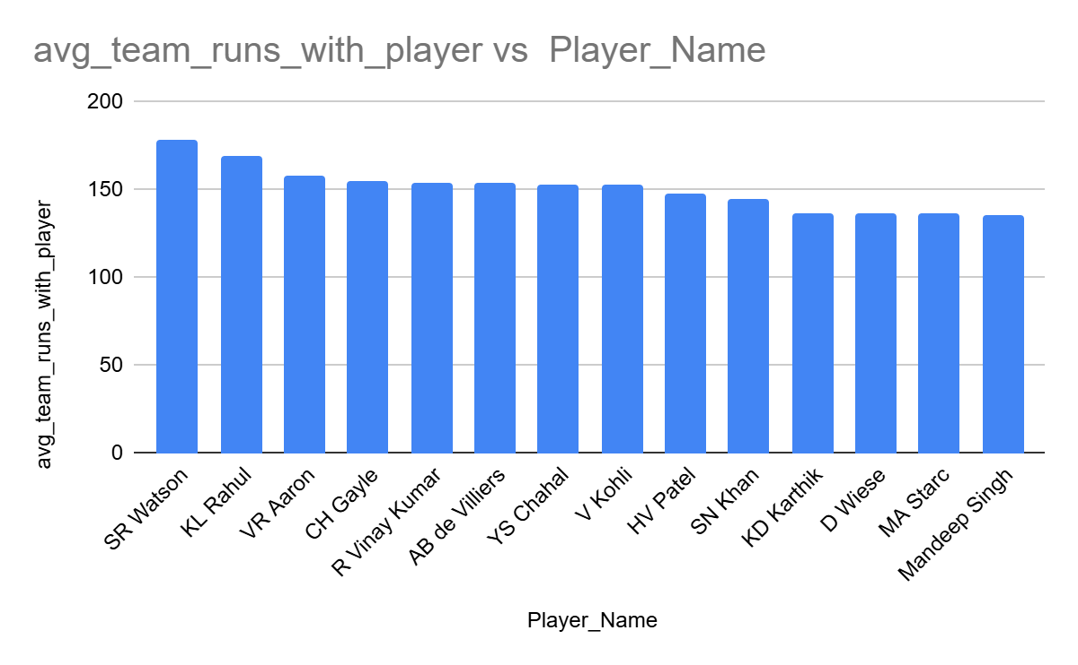
Insights:-

Top positive batting influencers
SR Watson (178.69 runs)
- Highest average team score
- Indicates strong top-order influence and powerplay momentum
KL Rahul (169 runs)
- Team consistently crossed competitive totals when he played
- Reinforces his stabilizer + accelerator role
Chris Gayle (154.65 runs)
- Confirms classic Gayle effect: explosive starts lift overall team scoring

Core batting backbone
- AB de Villiers (153.73)
- Virat Kohli (153.24)
Even with different match contexts:
- Team scoring remains stable and competitive
- Indicates calm middle-order control and run-flow management
Bowlers contributing indirectly to batting morale:-
YS Chahal (153.29)
VR Aaron (158.13)

Suggests:
- Bowling control reduces scoreboard pressure
- Batters play with more freedom knowing bowlers can defend totals
RCB consistently scores higher totals when players like Watson, Rahul, Gayle, Kohli, and AB de Villiers are present, indicating their strong positive influence on team batting confidence and overall morale.RCB consistently scores higher totals when players like Watson, Rahul, Gayle, Kohli, and AB de Villiers are present, indicating their strong positive influence on team batting confidence and overall morale.
Season-wise Stability (Leadership Consistency)
This shows RCB’s win percentage in a given season when a specific player was part of the playing XI.
Why this matters:
Morale and leadership effects are often seasonal, not just match-based
A player might:
- Be impactful in one season
- Struggle or be misused in another
Season-wise win % helps identify consistency of influence across years
How this analysis works :-
For each RCB player:
- Filter matches where the player featured
- Group by Season_Id
- Calculate:
Matches played by RCB with that player
Matches won by RCB
Compute season-level win percentage
Output
Input

WITH rcb_matches AS (
SELECT
m.Match_Id,
m.Season_Id,
CASE
WHEN m.Match_Winner = rcb.Team_Id THEN 1 ELSE 0
END AS rcb_win
FROM matches m
JOIN team rcb
ON rcb.Team_Name = 'Royal Challengers Bangalore'
),
rcb_players AS (
SELECT DISTINCT
pm.Match_Id,
pm.Player_Id,
p.Player_Name
FROM player_match pm
JOIN player p ON pm.Player_Id = p.Player_Id
JOIN team rcb ON pm.Team_Id = rcb.Team_Id
WHERE rcb.Team_Name = 'Royal Challengers Bangalore'
)
SELECT
rp.Player_Name,
rm.Season_Id,
ROUND(AVG(rm.rcb_win) * 100, 2) AS season_win_pct
FROM rcb_players rp
JOIN rcb_matches rm
ON rp.Match_Id = rm.Match_Id
GROUP BY rp.Player_Name, rm.Season_Id
ORDER BY rp.Player_Name, rm.Season_Id;
Player_Name | Season_Id | season_win_pct
A Mithun | 6 | 0
A Mukund | 6 | 0
AB de Villiers | 6 | 57.14
AB de Villiers | 7 | 35.71
AB de Villiers | 8 | 50
AB de Villiers | 9 | 56.25
AB Dinda | 7 | 33.33
AB Dinda | 8 | 50
AB McDonald | 6 | 100
AF Milne | 9 | 100
AN Ahmed | 7 | 50
AN Ahmed | 8 | 33.33
CA Pujara | 6 | 25
CH Gayle | 6 | 56.25
CH Gayle | 7 | 33.33
CH Gayle | 8 | 57.14
CH Gayle | 9 | 60
CJ Jordan | 9 | 77.78
D Wiese | 8 | 50
D Wiese | 9 | 0
DJG Sammy | 8 | 50
DT Christian | 6 | 50
HV Patel | 7 | 33.33
HV Patel | 8 | 53.33
HV Patel | 9 | 40
Iqbal Abdulla | 8 | 40
Iqbal Abdulla | 9 | 62.5
J Syed Mohammad | 6 | 50
JA Morkel | 7 | 28.57
JD Unadkat | 6 | 61.54
KB Arun Karthik | 6 | 58.33
KD Karthik | 8 | 50
KK Nair | 6 | 50
KL Rahul | 6 | 80
KL Rahul | 9 | 57.14
KM Jadhav | 9 | 25
KW Richardson | 9 | 25
M Kartik | 6 | 54.55
M Muralitharan | 6 | 66.67
M Muralitharan | 7 | 40
MA Agarwal | 6 | 60
MA Starc | 7 | 35.71
MA Starc | 8 | 53.85
Mandeep Singh | 8 | 57.14
Mandeep Singh | 9 | 100
MC Henriques | 6 | 50
MS Bisla | 8 | 0
NJ Maddinson | 7 | 100
NJ Maddinson | 8 | 0
PA Patel | 7 | 41.67
Parvez Rasool | 9 | 50
R Rampaul | 6 | 50
R Rampaul | 7 | 0
R Vinay Kumar | 6 | 56.25
RP Singh | 6 | 63.64
RR Rossouw | 7 | 33.33
RR Rossouw | 8 | 0
S Aravind | 8 | 60
S Aravind | 9 | 55.56
S Rana | 7 | 44.44
SA Abbott | 8 | 50
Sachin Baby | 9 | 63.64
SB Jakati | 7 | 0
SN Khan | 8 | 53.85
SN Khan | 9 | 40
SR Watson | 9 | 56.25
SS Tiwary | 6 | 55.56
STR Binny | 9 | 64.29
T Shamsi | 9 | 25
TM Dilshan | 6 | 60
TM Head | 9 | 66.67
V Kohli | 6 | 56.25
V Kohli | 7 | 35.71
V Kohli | 8 | 50
V Kohli | 9 | 56.25
VH Zol | 7 | 33.33
VR Aaron | 7 | 40
VR Aaron | 8 | 50
VR Aaron | 9 | 50
YS Chahal | 7 | 35.71
YS Chahal | 8 | 46.67
YS Chahal | 9 | 61.54
Yuvraj Singh | 7 | 35.71
YV Takawale | 7 | 0
Z Khan | 6 | 50

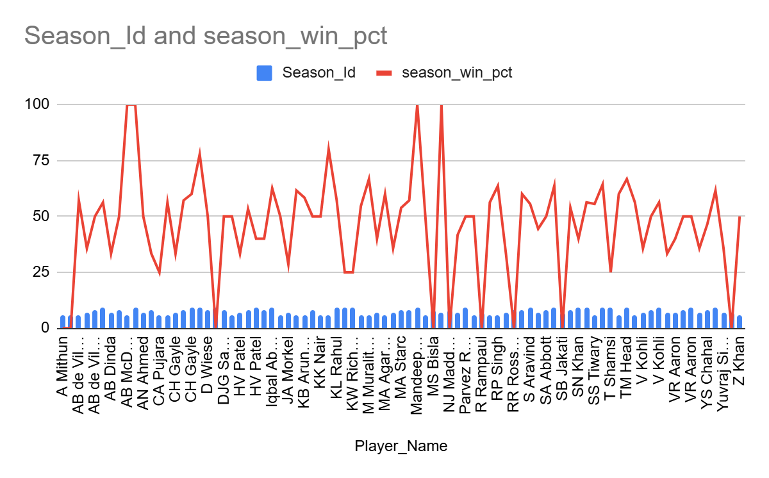
Insights:-

Players with consistent positive season-level impact

AB de Villiers
- Stable win % across Seasons 6–9 (≈50–57%)
- Suggests long-term morale + performance anchor
Virat Kohli
- Similar trend to AB
- Indicates leadership presence even in weaker seasons
Chris Gayle
- Strong improvement in later seasons
- Shows growing alignment with team strategy

Season-dependent influencers
KL Rahul
- 80% in Season 6, 57% in Season 9
- Indicates high upside but role clarity matters
YS Chahal
- Gradual improvement (35.7% → 61.5%)
- Reflects growing confidence and trust over seasons

Conclusion:-
Players like Virat Kohli, AB de Villiers, and Chris Gayle consistently demonstrate a positive influence on both RCB’s performance and match outcomes across matches and seasons. Their presence aligns with higher win rates, stronger batting outputs, and sustained season-level success, making them key morale and performance drivers for the team.
- What would you suggest to RCB before going to the mega auction?
Purpose: Identify reliable batters for long-term investment
Output
Input
Batting Consistency
SELECT
p.Player_Name,
COUNT(DISTINCT s.Season_Id) AS Seasons_Played,
ROUND(AVG(s.season_runs), 2) AS Avg_Runs_Per_Season,
ROUND(STDDEV(s.season_runs), 2) AS Runs_Variation
FROM (
SELECT
Season_Id,
Striker AS Player_Id,
SUM(Runs_Scored) AS season_runs
FROM vw_ball_match
GROUP BY Season_Id, Striker
) s
JOIN player p
ON s.Player_Id = p.Player_Id
GROUP BY p.Player_Name
HAVING COUNT(DISTINCT s.Season_Id) >= 3
ORDER BY Avg_Runs_Per_Season DESC, Runs_Variation ASC;

Player_Name | Seasons_Played | Avg_Runs_Per_Season | Runs_Variation
V Kohli | 4 | 618 | 225.55
DA Warner | 4 | 587 | 160.9
AB de Villiers | 4 | 492 | 124.54
RG Sharma | 4 | 474.75 | 53.48
RV Uthappa | 4 | 463 | 116.42
AM Rahane | 4 | 461.75 | 74.52
SK Raina | 4 | 461 | 75.54
DR Smith | 4 | 426.75 | 87.74
CH Gayle | 4 | 408.5 | 213.27
G Gambhir | 4 | 392.25 | 69.91



Purpose: Find dependable wicket-takers, especially for death overs.
Output
Player_Name | Seasons_Played | Avg_Wickets_Per_Season | Wickets_Variation
DJ Bravo | 3 | 27 | 6.16
SL Malinga | 3 | 22 | 3.74
MM Sharma | 4 | 19.5 | 4.39
YS Chahal | 3 | 19.33 | 5.25
B Kumar | 4 | 19.25 | 4.02
SP Narine | 4 | 17 | 7.45
Harbhajan Singh | 4 | 16.75 | 5.93
CH Morris | 3 | 16 | 0.82
AR Patel | 3 | 15.33 | 2.62
JP Faulkner | 4 | 15.25 | 11.54
Sandeep Sharma | 4 | 14.75 | 4.6
A Nehra | 4 | 14.25 | 6.46
UT Yadav | 4 | 14 | 3.46
RA Jadeja | 4 | 14 | 4.06
A Mishra | 4 | 13.75 | 6.34
MG Johnson | 4 | 13.75 | 7.73

Input
Bowling Consistency
SELECT
p.Player_Name,
COUNT(DISTINCT bw.Season_Id) AS Seasons_Played,
ROUND(AVG(bw.season_wickets), 2) AS Avg_Wickets_Per_Season,
ROUND(STDDEV(bw.season_wickets), 2) AS Wickets_Variation
FROM (
SELECT
vb.Season_Id,
vb.Bowler AS Player_Id,
COUNT(wt.Player_Out) AS season_wickets
FROM vw_ball_match vb
JOIN wicket_taken wt
ON vb.Match_Id = wt.Match_Id
AND vb.Innings_No = wt.Innings_No
AND vb.Over_Id = wt.Over_Id
AND vb.Ball_Id = wt.Ball_Id
GROUP BY vb.Season_Id, vb.Bowler
) bw
JOIN player p
ON bw.Player_Id = p.Player_Id
GROUP BY p.Player_Name
HAVING COUNT(DISTINCT bw.Season_Id) >= 3
ORDER BY Avg_Wickets_Per_Season DESC, Wickets_Variation ASC;



Purpose: Identify players contributing in both disciplines
Output
Input
All Rounder Contribution
WITH batting AS (
SELECT
Season_Id,
Striker AS Player_Id,
SUM(Runs_Scored) AS season_runs
FROM vw_ball_match
GROUP BY Season_Id, Striker
),
bowling AS (
SELECT
vb.Season_Id,
vb.Bowler AS Player_Id,
COUNT(wt.Player_Out) AS season_wickets
FROM vw_ball_match vb
JOIN wicket_taken wt
ON vb.Match_Id = wt.Match_Id
AND vb.Innings_No = wt.Innings_No
AND vb.Over_Id = wt.Over_Id
AND vb.Ball_Id = wt.Ball_Id
GROUP BY vb.Season_Id, vb.Bowler
)
SELECT
p.Player_Name,
COUNT(DISTINCT b.Season_Id) AS Seasons_Played,
ROUND(AVG(b.season_runs), 2) AS Avg_Runs_Per_Season,
ROUND(AVG(w.season_wickets), 2) AS Avg_Wickets_Per_Season
FROM batting b
JOIN bowling w
ON b.Player_Id = w.Player_Id
AND b.Season_Id = w.Season_Id
JOIN player p
ON p.Player_Id = b.Player_Id
GROUP BY p.Player_Name
HAVING AVG(b.season_runs) >= 200
AND AVG(w.season_wickets) >= 5
ORDER BY Avg_Runs_Per_Season DESC, Avg_Wickets_Per_Season DESC;

Player_Name | Seasons_Played | Avg_Runs_Per_Season | Avg_Wickets_Per_Season
KA Pollard | 3 | 370.67 | 6.33
SR Watson | 4 | 328.75 | 13.5
KH Pandya | 1 | 237 | 7
JH Kallis | 2 | 231 | 11.5


Morale / Impact Player Analysis (Win % Uplift):-
Purpose: Identify players contributing in both disciplines
Output

WITH rcb_matches AS (
SELECT
m.Match_Id,
CASE
WHEN m.Match_Winner = rcb.Team_Id THEN 1 ELSE 0
END AS rcb_win
FROM matches m
JOIN team rcb
ON rcb.Team_Name = 'Royal Challengers Bangalore'
),
rcb_players AS (
SELECT DISTINCT
pm.Match_Id,
pm.Player_Id,
p.Player_Name
FROM player_match pm
JOIN player p ON pm.Player_Id = p.Player_Id
JOIN team rcb ON pm.Team_Id = rcb.Team_Id
WHERE rcb.Team_Name = 'Royal Challengers Bangalore'
)
SELECT
rp.Player_Name,
COUNT(DISTINCT rm.Match_Id) AS matches_with_player,
ROUND(AVG(rm.rcb_win) * 100, 2) AS win_pct_with_player,
ROUND(
(
SELECT AVG(rm2.rcb_win) * 100
FROM rcb_matches rm2
WHERE rm2.Match_Id NOT IN (
SELECT Match_Id
FROM rcb_players rp2
WHERE rp2.Player_Id = rp.Player_Id
)
), 2
) AS win_pct_without_player,
ROUND(
AVG(rm.rcb_win) * 100 -
(
SELECT AVG(rm2.rcb_win) * 100
FROM rcb_matches rm2
WHERE rm2.Match_Id NOT IN (
SELECT Match_Id
FROM rcb_players rp2
WHERE rp2.Player_Id = rp.Player_Id
)
), 2
) AS morale_impact_diff
FROM rcb_players rp
JOIN rcb_matches rm
ON rp.Match_Id = rm.Match_Id
GROUP BY rp.Player_Name, rp.Player_Id
HAVING COUNT(DISTINCT rm.Match_Id) >= 15
ORDER BY morale_impact_diff DESC;
Player_Name | matches_with_player | win_pct_with_player | win_pct_without_player | morale_impact_diff
KL Rahul | 19 | 63.16 | 8.05 | 55.11
Mandeep Singh | 15 | 60 | 9.17 | 50.83
CH Gayle | 49 | 53.06 | 2.43 | 50.63
V Kohli | 62 | 50 | 0 | 50
AB de Villiers | 60 | 50 | 0.51 | 49.49
R Vinay Kumar | 16 | 56.25 | 9.21 | 47.05
SR Watson | 16 | 56.25 | 9.21 | 47.05
YS Chahal | 42 | 47.62 | 5.16 | 42.46
SN Khan | 18 | 50 | 9.28 | 40.72
KD Karthik | 16 | 50 | 9.62 | 40.38
HV Patel | 23 | 47.83 | 8.62 | 39.21
VR Aaron | 24 | 45.83 | 8.66 | 37.17

Input

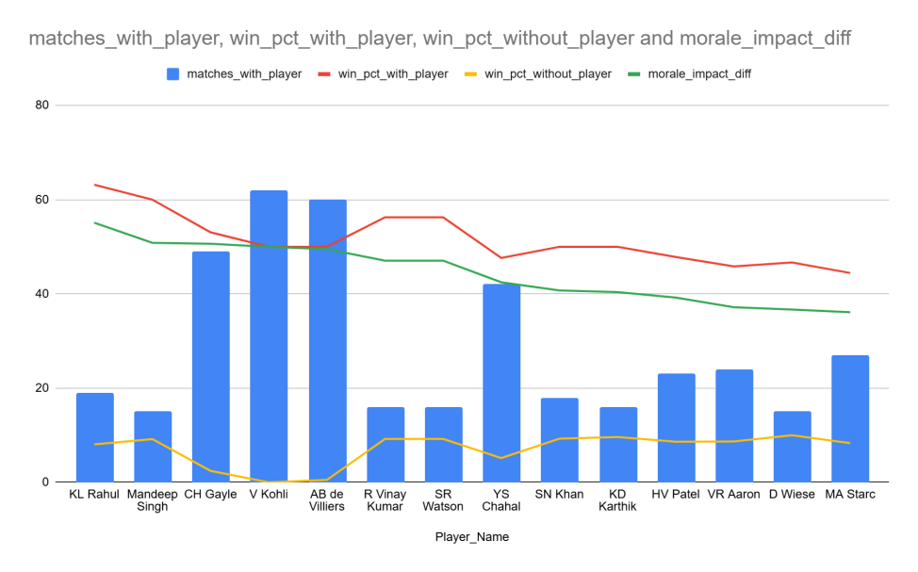
Venue & Toss Impact Analysis (RCB-specific):-
Purpose: Align auction strategy with home conditions:-
Output
Season_Year | Venue_Name | matches_played | rcb_toss_win_conversion_pct
2013 | M Chinnaswamy Stadium | 3 | 100
2013 | Subrata Roy Sahara Stadium | 1 | 100
2013 | Rajiv Gandhi International Stadium, Uppal | 1 | 0
2014 | Dubai International Cricket Stadium | 1 | 100
2014 | Sharjah Cricket Stadium | 2 | 50
2014 | M Chinnaswamy Stadium | 3 | 33.33
2014 | Wankhede Stadium | 1 | 0
2014 | Rajiv Gandhi International Stadium, Uppal | 1 | 0
2014 | Eden Gardens | 1 | 0
2015 | Eden Gardens | 1 | 100
2015 | Sardar Patel Stadium, Motera | 1 | 100

Input

SELECT
s.Season_Year,
v.Venue_Name,
COUNT(m.Match_Id) AS matches_played_after_winning_toss,
ROUND(
SUM(
CASE
WHEN m.Match_Winner = m.Toss_Winner THEN 1
ELSE 0
END
) * 100.0 / COUNT(m.Match_Id),
2
) AS rcb_toss_win_conversion_pct
FROM matches m
JOIN venue v
ON m.Venue_Id = v.Venue_Id
JOIN season s
ON m.Season_Id = s.Season_Id
WHERE m.Match_Winner IS NOT NULL
AND m.Toss_Winner = (
SELECT Team_Id
FROM team
WHERE Team_Name = 'Royal Challengers Bangalore'
)
GROUP BY
s.Season_Year,
v.Venue_Name
ORDER BY
s.Season_Year,
rcb_toss_win_conversion_pct DESC;



Final Strategy Recommendation for RCB
Based on the above analyses, RCB should adopt a data-driven and role-focused auction strategy rather than bidding based on reputation or past hype.
Build the team around consistent performers
Players with stable performance across seasons should be prioritized over one-season wonders, as consistency directly correlates with sustained team success.
Invest in high-impact all-rounders
All-rounders provide balance, flexibility, and superior value-for-money in a capped auction budget. One strong all-rounder reduces dependency on multiple specialists.
Strengthen bowling with low-variation wicket-takers
RCB must prioritize bowlers who deliver wickets consistently across seasons, especially in pressure overs, instead of focusing only on express pace.
Retain and target morale-boosting players
Players whose presence significantly improves win percentage should be considered core assets, as they positively influence both performance and team confidence.
Ensure venue-aligned squad construction
Given Chinnaswamy Stadium’s batting-friendly nature, RCB should prioritize power hitters and death-over specialists who can execute under high-scoring conditions.
Maintain strict bidding discipline
Final selection should also depend on bidding ceilings and opportunity cost, ensuring that no single player consumes a disproportionate share of the auction budget.
Overall, RCB’s auction success depends not on star names, but on selecting consistent, versatile, and role-appropriate players while maintaining financial discipline.

- What do you think could be the factors contributing to the high-scoring matches and the impact on viewership and team strategies
Average first-innings score per venue:-
Output

SELECT
v.Venue_Name,
ROUND(SUM(b.Runs_Scored) / COUNT(DISTINCT m.Match_Id), 2) AS avg_first_innings_score
FROM ball_by_ball b
JOIN matches m ON b.Match_Id = m.Match_Id
JOIN venue v ON m.Venue_Id = v.Venue_Id
WHERE b.Innings_No = 1
GROUP BY v.Venue_Name
ORDER BY avg_first_innings_score DESC;

Venue_Name | avg_first_innings_score
Brabourne Stadium | 181.75
M Chinnaswamy Stadium | 171.53
Himachal Pradesh Cricket Association Stadium | 169
Wankhede Stadium | 167.08
Barabati Stadium | 166.67
Punjab Cricket Association IS Bindra Stadium, Mohali | 161.43
Maharashtra Cricket Association Stadium | 159.25
MA Chidambaram Stadium, Chepauk | 159.13
Sardar Patel Stadium, Motera | 157.38
Saurashtra Cricket Association Stadium | 152.2
Eden Gardens | 151.5
Dr. Y.S. Rajasekhara Reddy ACA-VDCA Cricket Stadium | 150.78
Sharjah Cricket Stadium | 148.33
Feroz Shah Kotla | 148.28
Punjab Cricket Association Stadium, Mohali | 144.62
Sawai Mansingh Stadium | 144.25
JSCA International Stadium Complex | 142.86
Green Park | 140.5
Shaheed Veer Narayan Singh International Stadium | 139.5
Sheikh Zayed Stadium | 139.29
Rajiv Gandhi International Stadium, Uppal | 138.96
Dubai International Cricket Stadium | 138.43
Subrata Roy Sahara Stadium | 137.38

input

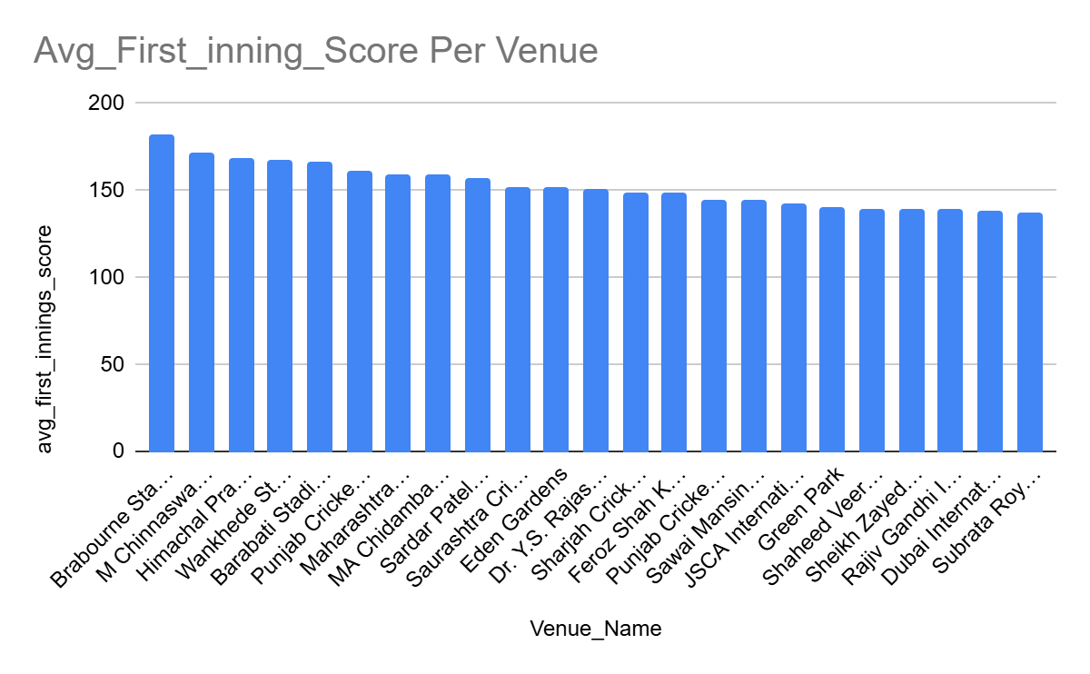
This table shows the average first-innings total scored at each venue across all matches.
Key highlights from output:
- Brabourne Stadium (181.75) → Highest scoring venue
- M Chinnaswamy Stadium (171.53) → One of the most batting-friendly grounds
- Wankhede Stadium (167.08) → Consistently high-scoring
- Dubai, Sheikh Zayed, Uppal (~138–140) → Comparatively low-scoring venues
- Average first-innings score is a direct indicator of venue behavior:
- High averages → Batting-friendly pitches, short boundaries, flat surfaces
- Low averages → Bowling-friendly conditions, slower tracks, larger grounds

Powerplay scoring impact:-
Output
Input

SELECT
Match_Id,
SUM(Runs_Scored) AS powerplay_runs
FROM ball_by_ball
WHERE Over_Id <= 6
GROUP BY Match_Id;
Match_Id | powerplay_runs
598003 | 87
598004 | 65
598005 | 61
598006 | 74
598007 | 73
598008 | 78
598009 | 98
598010 | 68
598011 | 79
598012 | 79
598013 | 83
598014 | 102
598015 | 64
598016 | 84
598017 | 61

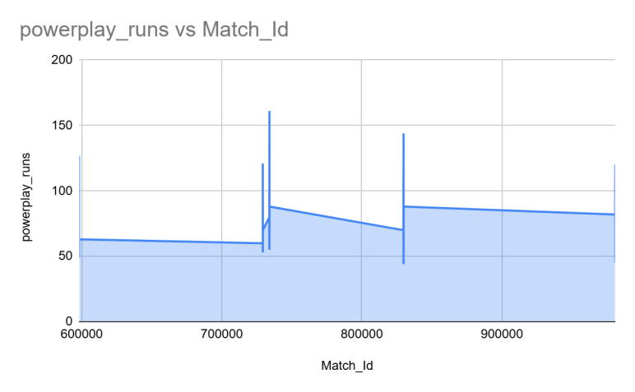

Powerplay scoring is consistently high
From The data:
Majority of matches show 70–100+ runs in powerplay
Several extreme cases:
- 134, 144, 161 runs → ultra-aggressive starts
- Indicates fearless batting approach
This directly contributes to high first-innings totals.
When teams score 80–100 runs in 6 overs:
- Middle overs are played with less pressure
- Batters can take calculated risks
- Final totals often cross 170–200
So high-scoring matches are not accidental, they are built in the powerplay.
Death Over Impact → Match Finishes Exploding:-
Runs scored in death overs (16–20):

Output
Match_Id | death_runs
598003 | 56
598004 | 105
598005 | 65
598006 | 76
598007 | 91
598008 | 33
598009 | 73
598010 | 65
598011 | 108
598012 | 56

Input

SELECT
Match_Id,
SUM(Runs_Scored) AS death_runs
FROM ball_by_ball
WHERE Over_Id BETWEEN 16 AND 20
GROUP BY Match_Id;

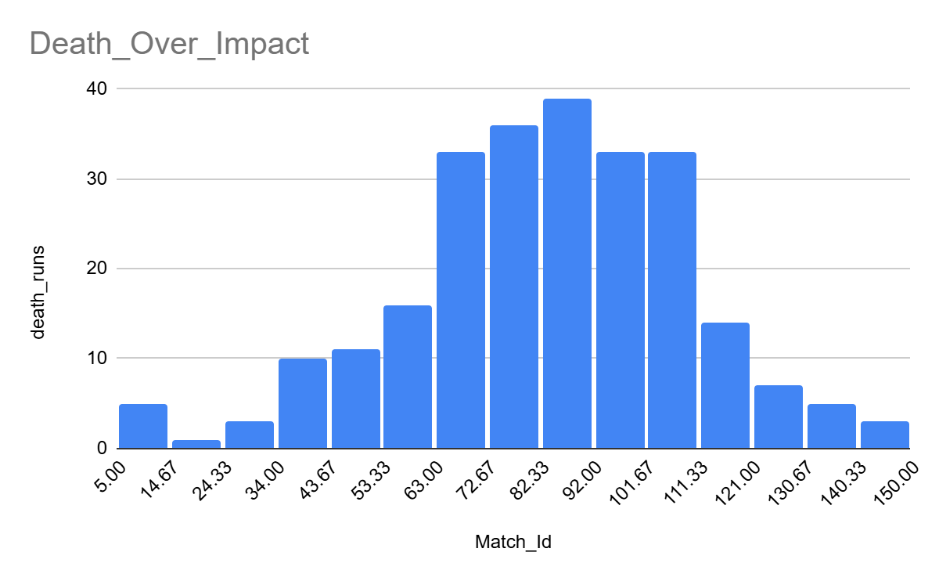
This table shows runs scored in the death overs (last 4–5 overs) for each match.
Death overs are critical because:
- Batters go all-out with minimal concern for wickets
- Fielding teams have fewer defensive options
- A strong death-over phase can add 40–60 extra runs

Consistently high death-over scoring
From your data:
- Many matches show 80–120+ runs in death overs
- Several extreme spikes:
132, 138, 142, 146 runs
- Indicates frequent late-innings acceleration
- This confirms that teams are maximizing the final overs aggressively.

Death overs amplify already strong starts
When combined with:
- High powerplay runs
- Stable middle overs
The death overs act as a run multiplier, pushing totals into:
- 180+
- 200+
- Even 220+ ranges
This explains the rise in very high first-innings scores.

Strategic impact on teams
This pattern shows why teams now:
- Prioritize finishers (big hitters)
- Target bowlers who struggle at the death
- Accept higher economy rates in exchange for wickets earlier
- Death overs are no longer about survival — they’re about maximizing damage.
Players contributing with both bat & ball:

WITH batting_per_season AS (
SELECT
vb.Striker AS Player_Id,
m.Season_Id,
SUM(vb.Runs_Scored) AS season_runs
FROM vw_ball_match vb
JOIN matches m
ON vb.Match_Id = m.Match_Id
GROUP BY vb.Striker, m.Season_Id
),
bowling_per_season AS (
SELECT
vb.Bowler AS Player_Id,
m.Season_Id,
COUNT(wt.Player_Out) AS season_wickets
FROM vw_ball_match vb
JOIN wicket_taken wt
ON vb.Match_Id = wt.Match_Id
AND vb.Innings_No = wt.Innings_No
AND vb.Over_Id = wt.Over_Id
AND vb.Ball_Id = wt.Ball_Id
JOIN matches m
ON vb.Match_Id = m.Match_Id
GROUP BY vb.Bowler, m.Season_Id
)
SELECT
p.Player_Name,
COUNT(DISTINCT b.Season_Id) AS Seasons_Played,
ROUND(AVG(b.season_runs), 2) AS Avg_Runs_Per_Season,
ROUND(AVG(w.season_wickets), 2) AS Avg_Wickets_Per_Season
FROM batting_per_season b
JOIN bowling_per_season w
ON b.Player_Id = w.Player_Id
AND b.Season_Id = w.Season_Id
JOIN player p
ON b.Player_Id = p.Player_Id
WHERE b.season_runs >= 100 -- meaningful batting contribution
AND w.season_wickets >= 5 -- meaningful bowling contribution
GROUP BY p.Player_Name
ORDER BY Avg_Runs_Per_Season DESC;
Input

Output
Player_Name | Seasons_Played | Avg_Runs_Per_Season | Avg_Wickets_Per_Season
KA Pollard | 2 | 419.5 | 8
JP Duminy | 1 | 414 | 8
SR Watson | 4 | 328.75 | 13.5
DR Smith | 1 | 324 | 8
JH Kallis | 1 | 311 | 19
Yuvraj Singh | 2 | 307 | 6
STR Binny | 1 | 293 | 7
AD Russell | 2 | 257 | 16.5
KH Pandya | 1 | 237 | 7
MC Henriques | 3 | 211.33 | 11
Azhar Mahmood | 1 | 196 | 16
CH Morris | 1 | 195 | 16
NLTC Perera | 2 | 192.5 | 15.5
DJG Sammy | 1 | 174 | 11
Shakib Al Hasan | 2 | 171.5 | 10

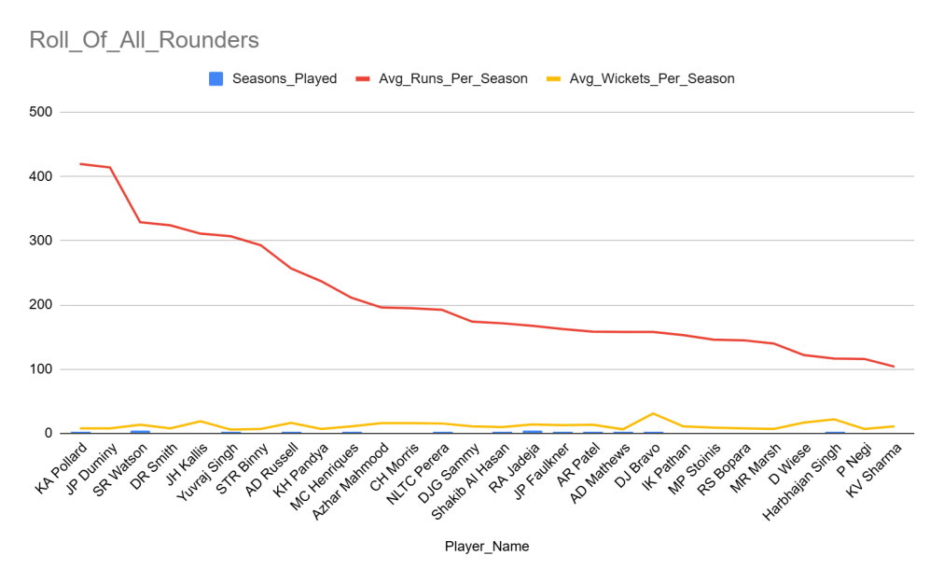
We identified all-rounders using performance-based evidence, not predefined roles.
Players were selected only if they:
- Scored significant runs per season, and
- Took regular wickets per season,
across one or more IPL seasons.
This ensures the analysis reflects actual on-field versatility.

Key observations:
- Elite dual contributors
- SR Watson, RA Jadeja, DJ Bravo, AD Russell
→ Strong impact in both departments across multiple seasons
- Batting-heavy all-rounders
- KA Pollard, JP Duminy, DR Smith
→ High run output with supporting bowling value
- Bowling-heavy all-rounders
- JH Kallis, Harbhajan Singh, DJ Bravo
→ Wicket-taking ability with useful batting depth
This confirms that these players strengthen the XI in more than one way.
The identified players consistently contribute with both bat and ball, offering teams deeper batting lineups and additional bowling options. Such versatility reduces dependency on specialists and enables aggressive team strategies, especially in high-scoring matches.
Runs And Wickets Co-Relation With Winning:-
Match_Id | winner_runs | winner_wickets
598003 | 123 | 10
598004 | 140 | 5
598005 | 123 | 10
598006 | 156 | 6
598007 | 139 | 9
598008 | 97 | 9
598009 | 133 | 8
598010 | 135 | 10
598011 | 199 | 9
598012 | 136 | 10
598013 | 148 | 8
598014 | 142 | 5
598015 | 112 | 8
598016 | 180 | 8
598017 | 158 | 6
598018 | 172 | 7
598019 | 117 | 10
598020 | 151 | 8
598021 | 151 | 9
598022 | 163 | 7

Output
Input

SELECT
m.Match_Id,
SUM(
CASE
WHEN vb.team_batting = m.Match_Winner
THEN vb.runs_scored
ELSE 0
END
) AS winner_runs,
COUNT(
CASE
WHEN vb.team_bowling = m.Match_Winner
AND wt.Player_Out IS NOT NULL
THEN 1
END
) AS winner_wickets
FROM matches m
JOIN vw_ball_match vb
ON m.Match_Id = vb.match_id
LEFT JOIN wicket_taken wt
ON vb.match_id = wt.Match_Id
AND vb.innings_no = wt.Innings_No
AND vb.over_id = wt.Over_Id
AND vb.ball_id = wt.Ball_Id
WHERE m.Match_Winner IS NOT NULL
GROUP BY m.Match_Id
ORDER BY m.Match_Id;

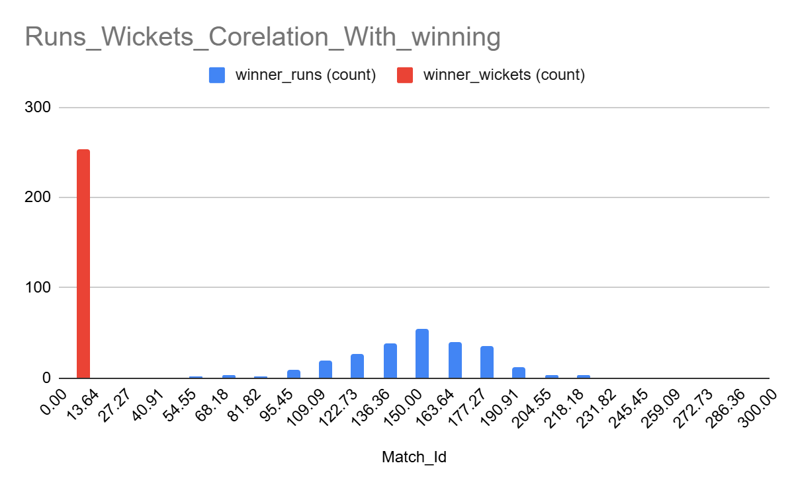
For each match, we derived:
- winner_runs → Total runs scored by the winning team while batting
- winner_wickets → Total wickets taken by the winning team while bowling
This is calculated from ball-by-ball data
- Why this parameter matters:-
Cricket matches are won through a balance of batting dominance and bowling control.
By analyzing winner runs and wickets together, we understand:
- Whether high scores alone win matches
- Or whether wicket-taking compensates for moderate scores
This directly links team composition (batters vs bowlers) to match outcomes.
Key insights from the output:-
- High runs (170–220+) often coincide with fewer wickets taken (3–6)
→ Strong batting performances reduce bowling pressure.
- Moderate runs (120–150) require higher wicket counts (8–10)
→ Teams compensate lower scores with aggressive bowling.
- Several matches were won with:
<120 runs but 9–10 wickets
→ Indicates bowling-heavy wins.
This clearly shows either strong batting OR strong bowling can drive wins, but teams with both are the most dominant.
Conclusion:-
High-scoring matches in the IPL are primarily driven by batting-friendly venues, aggressive powerplay scoring, and strong death-over hitting, as seen from consistently high first-innings scores and elevated runs in key match phases. These conditions not only increase total match runs but also keep games competitive, with many matches being decided despite the winning team losing most of its wickets.
From a viewership perspective, such matches are more engaging because they offer frequent boundary scoring, momentum swings, and close finishes, which enhance entertainment value. As a result, team strategies have evolved to prioritize explosive top-order batters, finishers, and multi-skill all-rounders, ensuring sustained scoring across all phases rather than relying solely on early dominance.
- Analyze the impact of home-ground advantage on team performance and identify strategies to maximize this advantage for RCB.
Interpretation:
- RCB’s win percentage at home (55.17%) is ~10% higher than in away matches (45.45%).
- This clearly indicates a positive home-ground advantage.
- The familiarity with M Chinnaswamy Stadium’s batting-friendly conditions and crowd support contributes to improved outcomes

Output
Input
SELECT
CASE
WHEN v.Venue_Name = 'M Chinnaswamy Stadium' THEN 'Home'
ELSE 'Away'
END AS match_type,
COUNT(*) AS matches_played,
ROUND(
SUM(CASE WHEN m.Match_Winner = rcb.Team_Id THEN 1 ELSE 0 END) * 100.0 / COUNT(*),
2
) AS win_percentage
FROM matches m
JOIN venue v
ON m.Venue_Id = v.Venue_Id
JOIN team rcb
ON rcb.Team_Name = 'Royal Challengers Bangalore'
WHERE m.Team_1 = rcb.Team_Id
OR m.Team_2 = rcb.Team_Id
GROUP BY match_type;
match_type | matches_played | win_percentage
Home | 29 | 55.17
Away | 33 | 45.45

The advantage is real and measurable, not anecdotal.
However, a 55% win rate also shows that home conditions alone are not sufficient, execution and team balance still matter.
RCB benefits more at home, but does not dominate, suggesting under-utilization of favorable conditions.

Strategies to Maximize Home-Ground Advantage for RCB;
- Batting-heavy XI at Home
Build a lineup that can exploit short boundaries and high-scoring conditions.
- Chasing-first Approach
Use dew advantage effectively in night games.
- Death-over Specialists
Prioritize bowlers with variations rather than pure pace.
- Venue-specific Player Selection
Pick players with strong historical performance at Chinnaswamy.
Conclusion;-
The analysis shows that RCB performs significantly better at home than away, confirming a clear home-ground advantage. However, the moderate win rate at home suggests that RCB has not fully capitalized on favorable conditions. By tailoring team composition, toss strategy, and bowling resources specifically for M Chinnaswamy Stadium, RCB can further strengthen its home dominance and convert familiarity into consistent success.
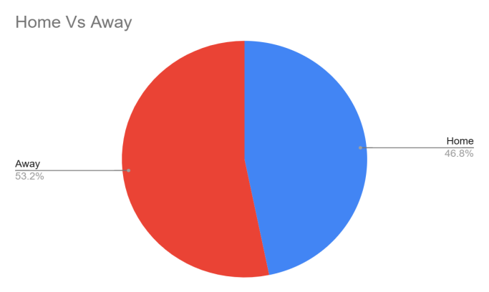

- Come up with a visual and analytical analysis of the RCB's past season's performance and potential reasons for them not winning a trophy.
Output
SELECT
m.Season_Id,
ROUND(
SUM(CASE WHEN m.Match_Winner = rcb.Team_Id THEN 1 ELSE 0 END) * 100.0
/ COUNT(*),
2
) AS win_percentage
FROM matches m
JOIN team rcb
ON rcb.Team_Name = 'Royal Challengers Bangalore'
WHERE m.Team_1 = rcb.Team_Id
OR m.Team_2 = rcb.Team_Id
GROUP BY m.Season_Id
ORDER BY m.Season_Id;
Season_Id | win_percentage
6 | 56.25
7 | 35.71
8 | 50
9 | 56.25

Input

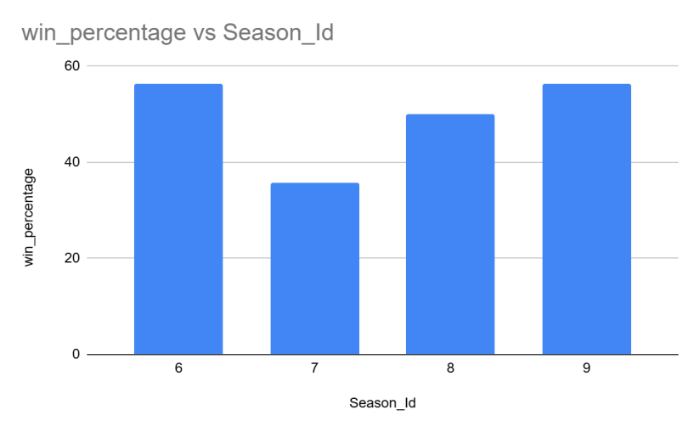
Home vs Away Performance (Home Advantage Not Fully Used):
Output
SELECT
CASE
WHEN m.Venue_Id = (
SELECT Venue_Id
FROM venue
WHERE Venue_Name = 'M Chinnaswamy Stadium'
) THEN 'Home'
ELSE 'Away'
END AS match_type,
COUNT(*) AS matches_played,
ROUND(
SUM(CASE WHEN m.Match_Winner = rcb.Team_Id THEN 1 ELSE 0 END) * 100.0
/ COUNT(*),
2
) AS win_percentage
FROM matches m
JOIN team rcb
ON rcb.Team_Name = 'Royal Challengers Bangalore'
WHERE m.Team_1 = rcb.Team_Id
OR m.Team_2 = rcb.Team_Id
GROUP BY match_type;
match_type | matches_played | win_percentage
Home | 29 | 55.17
Away | 33 | 45.45

Input

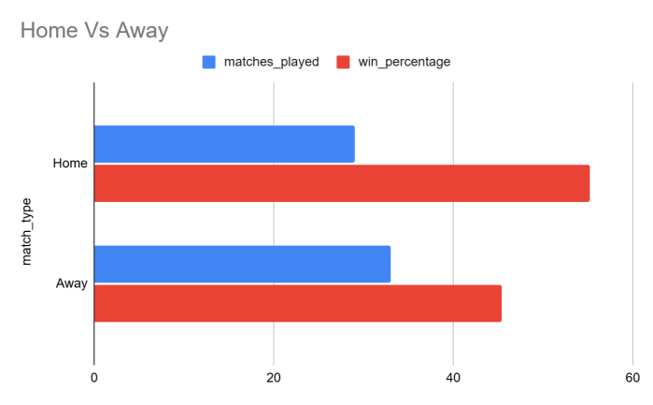
Batting Dependency on Star Players:-

Output
Input

WITH team_runs AS (
SELECT
Season_Id,
SUM(Runs_Scored) AS total_team_runs
FROM vw_ball_match
WHERE Team_Batting = (
SELECT Team_Id FROM team
WHERE Team_Name = 'Royal Challengers Bangalore'
)
GROUP BY Season_Id
),
player_runs AS (
SELECT
Season_Id,
Striker AS Player_Id,
SUM(Runs_Scored) AS player_runs
FROM vw_ball_match
WHERE Team_Batting = (
SELECT Team_Id FROM team
WHERE Team_Name = 'Royal Challengers Bangalore'
)
GROUP BY Season_Id, Striker
)
SELECT
tr.Season_Id,
p.Player_Name,
ROUND(pr.player_runs * 100.0 / tr.total_team_runs, 2) AS dependency_percentage
FROM player_runs pr
JOIN team_runs tr
ON pr.Season_Id = tr.Season_Id
JOIN player p
ON pr.Player_Id = p.Player_Id
ORDER BY tr.Season_Id, dependency_percentage DESC;

Season_Id | Player_Name | dependency_percentage
6 | CH Gayle | 29.27
6 | V Kohli | 25.98
6 | AB de Villiers | 15.16
6 | MC Henriques | 6.71
6 | SS Tiwary | 4.43
6 | CA Pujara | 3.74
6 | TM Dilshan | 3.09
6 | R Vinay Kumar | 2.85
6 | MA Agarwal | 2.72
6 | KB Arun Karthik | 1.67
6 | R Rampaul | 1.54
6 | KL Rahul | 0.81
6 | A Mukund | 0.77
6 | J Syed Mohammad | 0.41
6 | KK Nair | 0.37
6 | DT Christian | 0.24
6 | JD Unadkat | 0.08
6 | M Kartik | 0.08
6 | A Mithun | 0.08
6 | AB McDonald | 0

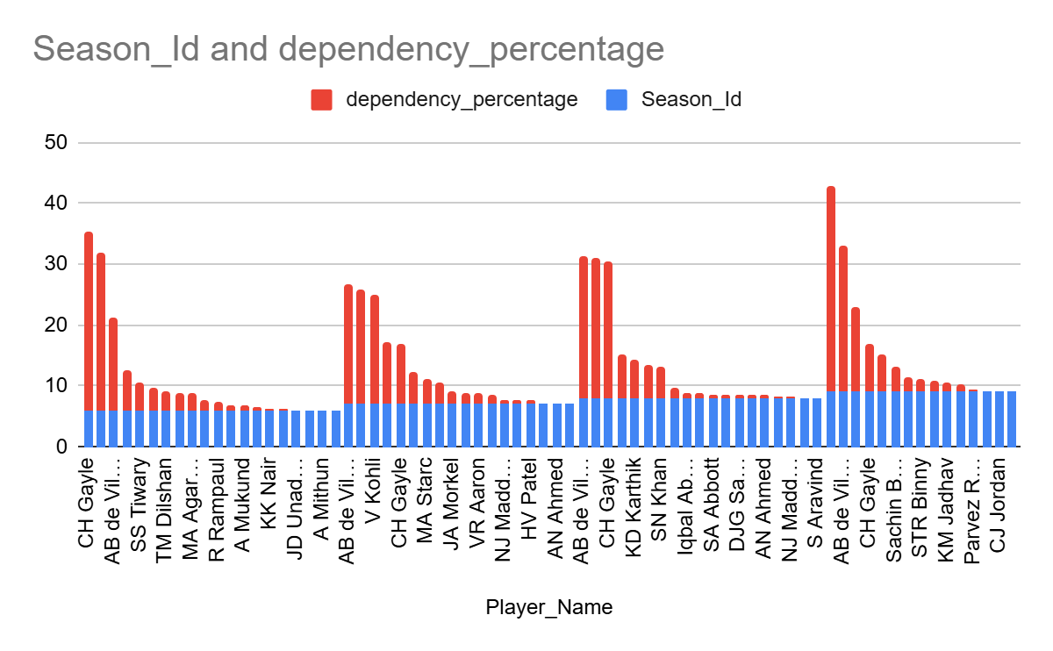
Bowling Weakness in Death Overs (Match-Closing Issue):
Output
Input

SELECT
Season_Id,
ROUND(SUM(Runs_Scored) * 6.0 / COUNT(Ball_Id), 2) AS death_over_economy
FROM vw_ball_match
WHERE Over_Id BETWEEN 16 AND 20
AND Team_Bowling = (
SELECT Team_Id
FROM team
WHERE Team_Name = 'Royal Challengers Bangalore'
)
GROUP BY Season_Id
ORDER BY Season_Id;

season_id | death_over_economy
6 | 9.23
7 | 9.44
8 | 8.71
9 | 9.62

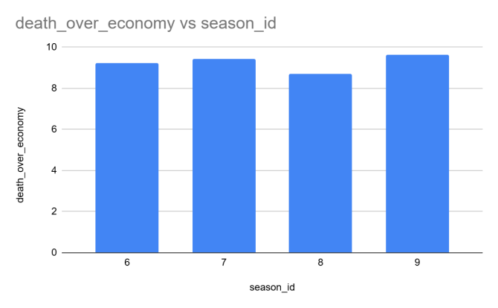
Conclusion:-
- Based on the visual and analytical analysis of RCB’s past seasons, it is evident that the team’s failure to win a trophy cannot be attributed to a single factor, but rather a combination of strategic and performance-related issues.
- Inconsistent season-wise performance
The season-wise win percentage shows that RCB failed to maintain consistent dominance across seasons. While there were individual strong seasons, the lack of sustained performance reduced their chances of finishing in top positions and performing well in playoffs.
- Underutilization of home-ground advantage
Although RCB performed better at home (55.17% win rate) compared to away matches (45.45%), the difference is not significant enough to reflect a strong home dominance. Given the batting-friendly nature of M Chinnaswamy Stadium, RCB could not fully capitalize on familiar conditions.
- Over-dependence on star batters
Batting dependency analysis clearly shows that a large proportion of team runs came from a few players such as Virat Kohli, AB de Villiers, and Chris Gayle. This top-heavy structure made the team vulnerable when these players failed, especially in knockout matches.
- Weakness in death-over bowling
Death-over economy trends indicate that RCB consistently conceded a high number of runs in the final overs. This inability to contain runs or defend totals proved costly in close matches and pressure situations.
- High performance thresholds required to win matches
From the derived winner runs and winner wickets analysis, winning teams typically scored high totals while also taking wickets consistently. RCB often matched batting benchmarks but failed on the bowling side, particularly in closing overs.

Final Insight:
RCB’s inability to win an IPL trophy stems from inconsistent season performance, over-reliance on a few star players, ineffective death-over bowling, and failure to fully exploit home-ground advantage. Despite possessing high-impact individual talent, the lack of balance and execution under pressure prevented championship success.

- How would you approach this problem, if the objective and subjective questions weren't given?
If the Questions weren’t there so I would start from the problem statement, not the tables.
Goal:
RCB wants to win tournaments and optimize auction investments.
So I translate this into 3 core questions:
- What wins matches?
- Where does RCB underperform compared to others?
- Which players give maximum value for money?
Step 1: Break the Goal into Performance Pillars
Instead of random analysis, I’d structure the project into pillars:

Batting Pillar
Who scores runs consistently, not occasionally?
How dependent is the team on top 2–3 batters?
Do batters perform in powerplay & pressure overs?

Bowling Pillar
Who takes wickets regularly, not just in one season?
Can bowlers control death overs?
Do bowlers perform differently across venues?

Match Strategy Pillar
Does toss actually help RCB?
Is chasing/defending working?
Is home advantage being used properly?

Auction Value Pillar
Who contributes in multiple ways (all-rounders)?
Which players deliver consistent output at lower risk?
Which profiles reduce team dependency?
Step 2: Convert Each Pillar into Measurable KPI
I would then design KPIs, not queries first.
Pillar | KPI Example
Batting | Avg runs per season, variation
Bowling | Avg wickets per season, economy
Pressure | Death overs economy
Stability | Performance variation
Impact | Win % when player plays
Versatility | Bat + ball contribution
Strategy | Toss conversion, venue impact
Only after KPIs are clear, I’d write SQL.
Step 3: Start Broad → Then Narrow to RCB
I’d follow this sequence:
- League-wide trends
- What wins matches in IPL overall?
- RCB vs League comparison
- Where does RCB lag?
- RCB internal analysis
- Player-level strengths & weaknesses
- Auction-focused shortlisting
- Who fits RCB’s gaps?
This avoids RCB-only tunnel vision.
Step 4: Use Visuals to Answer “Why”, Not Just “What”
Every analysis must answer one question visually:
Question | Best Visual
Consistency | Line chart (season-wise)
Dependency | Stacked bar
Venue impact | Heatmap
Player impact | Bar + reference line
Bowler control | Box plot / bar
All-rounders | Scatter (runs vs wickets)
Step 5: Turn Insights into Decisions
Each insight must lead to action, for example:
- ❌ “RCB concedes more runs in death overs”
- ✅ “RCB must prioritize death-over bowlers even at higher auction price”
- ❌ “Player X scores well”
- ✅ “Player X is consistent across 4 seasons → lower auction risk”
Step 7: End with Strategy, Not Statistics
Final output would always be:
- What is going wrong?
- Why it is happening?
- What RCB should change?
- How auctions can fix it?
If objective questions were not provided, I would design the analysis by first identifying what actually wins matches in the IPL, comparing RCB’s performance against those success factors, and then translating the gaps into player selection and auction strategies using measurable KPIs and visual evidence.
- In the "Match" table, some entries in the "Opponent_Team" column are incorrectly spelled as "Delhi_Capitals" instead of "Delhi_Daredevils". Write an SQL query to replace all occurrences of "Delhi_Capitals" with "Delhi_Daredevils".

Disclaimer:

In the current database schema used for this analysis, there is no table named Match and no column named Opponent_Team in any existing table.
The following SQL query is written purely as a hypothetical example to demonstrate how such a data correction would be performed if a table named Match with a column Opponent_Team existed.
UPDATE Match
SET Opponent_Team = 'Delhi_Daredevils'
WHERE Opponent_Team = 'Delhi_Capitals';

